

CAPSTONE PROJECT REPORT
Report 4 – Software Design Specification

– Hanoi, Aug 2026 –

Table of Contents
Change Log 3
I. High Level Design 4
1. Software Architecture 4
2. Package Diagram 6
2.1 Web Package Diagram (React 18 / Vite) 6
2.2 Mobile Package Diagram (Flutter Clean Architecture) 7
3. Database Design 10
3.1 table_name1 11
3.2 users 11
3.3 table_name3 12
II. Detailed Code Design 12
1. Workforce Preparation, Matching & Assignment (FE-02 to FE-08) 12
1.1 Class Diagrams 12
1.2 Sequence Diagrams 14
2. Work Execution, Payment Confirmation & Reputation (FE-09 to FE-11) 23
3. Account, Subscription & Platform Administration (FE-01, FE-12, FE-13, SUP) 23
III. Design for Non-Functional Requirements 23
1. Security Design 23
1.1 Authentication Flow 24
1.2 Authorization & RBAC Implementation 25
1.3 Data Protection 26
2. Performance & Scalability Design 27
2.1 Caching Strategy 27
2.2 Database Query Optimization 28
IV. Other Design Specifications 29

Change Log
Date | A*  M, D | In charge | Change Description
10/10/2026 | A | HungPD | Add High Level Design include Software Architecture and Package Diagram
11/10/2026 | A | MinhTB | Add Database Design and all table and their attribute
11/10/2026 | A | HungPD | Add Detail Code Design Workforce Preparation, Matching & Assignment (FE-02 to FE-08)
12/10/2026 | A | QuyTH | Add Detail code Design Account, Subscription & Platform Administration (FE-01, FE-12, FE-13, SUP)
12/10/2026 | A | DuongMH | Add Detail Code Design Work Execution, Payment Confirmation & Reputation (FE-09 to FE-11)
13/10/2026 | A | QuyTH | Add Design for non-functional requirement and Other design specifications
15/10/2026 | M | KhanhDT | Change and update parts of non-functional requirements
16/10/2026 | M | DuongMH | Break down parts of the sequence diagram to avoid excessive complexity.
18/10/2026 | M | MinhTB | Check and refactor parts of the report resulting from changes to the project scope.
*A - Added M - Modified D - Deleted

I. High Level Design

1. Software Architecture
The CANi platform is architected as a Modular Monolith adopting Clean Architecture principles across three distinct physical and logical tiers: the Client Tier (Presentation), the Application Tier (Business Logic & Core Services), and the Data Tier (Persistence & Infrastructure). This architecture strictly decouples the user-facing web and mobile interfaces from domain business rules, guaranteeing transaction integrity for shift allocation, direct wage settlement verification, and subscription package billing, with high concurrency during shift matching and clean maintainability across team modules.
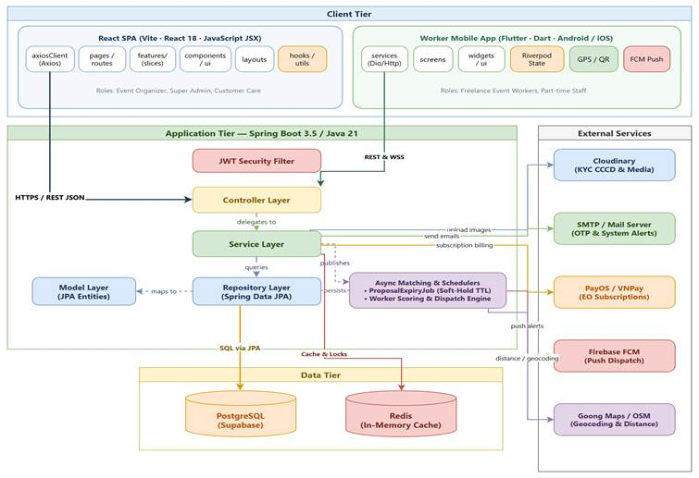
Figure 1: CANi Software Architecture Diagram (3-Tier Clean Architecture)
Architecture Component Descriptions
The software architecture comprises three primary tiers and integrated external services as detailed in Table 1 below:
No | Tier / Component | Description & Responsibilities
01 | Client Tier:  Web Portal (React 18) | Single Page Application (Vite, React 18, JavaScript JSX, Modular CSS) serving Event Organizers (event/shift creation, attendance monitor, payment proof declaration, and subscription package management), Super Admin, and Customer Care.
02 | Client Tier:  Mobile App (Flutter 3) | Cross-platform mobile application (Dart, BLoC pattern, Android & iOS) serving Freelance Event Workers and Shift Leaders for real-time shift discovery, proposal acceptance, and QR attendance scanning.
03 | Application Tier:  Presentation Layer | REST Controllers, WebSocket STOMP Message Broker, and Spring Security Filter Chain (JWT validation, RBAC enforcement, rate limiting, and centralized GlobalExceptionHandler).
04 | Application Tier:  Business Logic Layer | Encapsulates core domain business logic: Shift Matching & Worker Dispatch Engine, Soft-Hold TTL concurrency locks (Redis), Direct Wage Settlement & Payment Proof Verification, Subscription Package Billing, QR attendance validation, and Async scheduled jobs.
05 | Application Tier:  Data Access Layer | Spring Data JPA Repository interfaces, derived queries, database transactions (@Transactional), and Hibernate ORM persistence mapping.
06 | Data Tier:  PostgreSQL 16 | Primary ACID-compliant relational database storing core schemas: Users, Roles, Events, Shifts, Proposals, Shift Assignments, Attendance records, Payments, Payment Logs, Subscriptions, Disputes, and Reliability Logs. Managed in staging on Supabase cloud infrastructure (via standard JDBC connection pooling) and locally orchestrated via Docker Compose for zero-latency development.
07 | Data Tier:  Redis 7 Cache | In-memory cache and distributed lock manager: Manages Soft-Hold TTL locks during proposal consideration, token revocation blacklists, rate limiting counters, and real-time worker GPS coordinates.
08 | External Service:  PayOS / VNPay | Payment gateway integration (PayOS / VNPay) handling secure Event Organizer subscription package purchases (INVITE_ONLY, MATCHING_PLUS), checkout verification webhooks, and automated quota allocation.
09 | External Service:  Cloudinary CDN | High-performance cloud storage and CDN for secure worker KYC citizen identification cards (CCCD), event media proofs, and profile avatars.
10 | External Service:  Firebase FCM | Real-time push notification delivery to mobile workers for immediate shift broadcast invitations, assignment confirmations, and emergency shift cancellations.
11 | External Service:  Goong Maps / OSM | Geocoding and reverse geocoding API calculating exact distance and travel route estimation between worker location and event venues.
12 | External Service:  SMTP Mail Server | Automated transactional email notifications for account registration OTPs, password recovery, billing invoices, and contract dispute alerts.

2. Package Diagram
The package architecture of the CANi platform focuses on the two primary client sub-systems developed for user interaction: the Web Application (client.web) and the Mobile Application (client.mobile). Each sub-system enforces modular package partitioning, high cohesion, and strict dependency boundaries to ensure decoupled development, maintainability, and code reusability across platforms.

2.1 Web Package Diagram (React 18 / Vite)
The Web application serves Event Organizers, Super Admins, and Customer Care. Developed with React 18 and Vite using JavaScript JSX, it is structured under the src root directory into modular, decoupled packages (pages, components, schemas, store, hooks, services, lib, types, and constants) with clear dependency boundaries as shown in Figure 2.1:
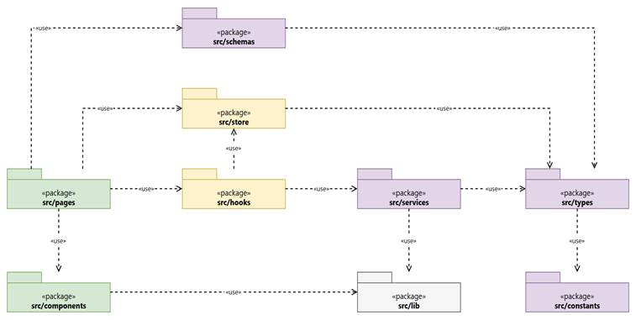
Figure 2.1: CANi Web Package Diagram
Package descriptions and file naming conventions for the Web sub-system are detailed in Table 2.1:
No | Package | Description | File Naming Convention
01 | src/pages | Top-level route and portal page views (Admin, Event Organizer, Customer Care) organizing feature workflows and layout wrappers. | PascalCase *.jsx
02 | src/components | Reusable presentation components (atomic common controls, feedback modals, tables, and navigation bars). | PascalCase *.jsx
03 | src/schemas | Data schema and client-side form validation definitions (Zod / Yup) ensuring payload integrity. | camelCase *Schema.js
04 | src/store | Global client state stores and persistent sessions (Zustand / Context API) for authentication and operational state. | camelCase *Store.js
05 | src/hooks | Application-wide reusable React hooks for reactive state, lifecycle bindings, and DOM utilities (useDebounce, useLocalStorage). | camelCase use*.js
06 | src/services | Centralized HTTP API client services managing network requests, data fetching, and backend endpoints. | camelCase *Service.js
07 | src/lib | Third-party library configuration and singleton client instances (Axios client with JWT interceptors, Day.js, Socket.IO client). | camelCase *.js
08 | src/types | Shared data model contracts, payload definitions, and entity prop interfaces. | camelCase *.js / *Types.js
09 | src/constants | Static application constants including route paths, user role definitions, status enums, and UI themes. | UPPER_SNAKE / camelCase *.js

2.2 Mobile Package Diagram (Flutter Clean Architecture)
The Mobile application is developed for freelance Event Workers and Shift Leaders. Built with Flutter 3 and Dart, it strictly implements Clean Architecture across Presentation, Domain, Data, and Core layers. Dependencies point inward toward the Domain layer, guaranteeing that business rules remain completely decoupled from the UI framework and external data sources as illustrated in Figure 2.2:
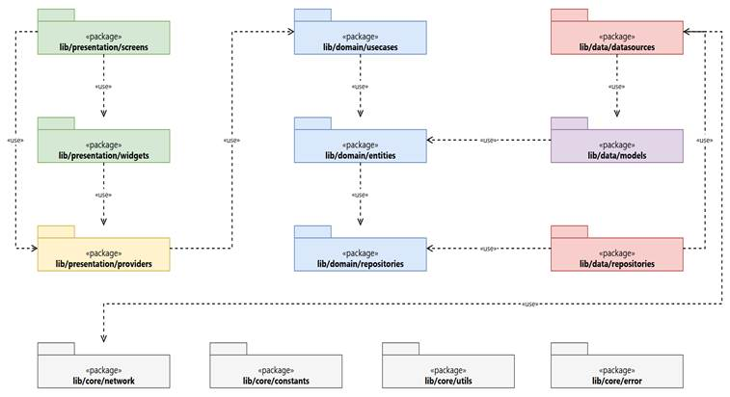
Figure 2.2: CANi Mobile Package Diagram (Flutter Clean Architecture & Riverpod)
Package descriptions and class naming conventions for the Mobile sub-system are detailed in Table 2.2:
No | Package | Layer | Description | Class / File Naming
01 | lib/presentation/screens | Presentation | Full-screen user views: LoginScreen, ShiftFeedScreen, ProposalModal, QrScanScreen, PaymentConfirmScreen. | *Screen.dart  (e.g., ShiftFeedScreen)
02 | lib/presentation/widgets | Presentation | Reusable UI components: ShiftCard, CountdownTimerWidget, RatingStars, QrScannerOverlay. | *Widget.dart  *Card.dart
03 | lib/presentation/providers | Presentation | Riverpod state management: Reactive StateNotifier and AsyncNotifier providers coordinating UI interactions with Domain use cases. | *Provider.dart  *Notifier.dart, *State.dart
04 | lib/domain/usecases | Domain | Atomic business use cases: GetAvailableShifts, AcceptProposal, CheckInQrAttendance, RequestPayout. | *UseCase.dart  (e.g., AcceptProposal)
05 | lib/domain/entities | Domain | Pure Dart domain entities with zero framework dependencies: ShiftEntity, WorkerProfileEntity, AttendanceRecord. | *Entity.dart  (e.g., ShiftEntity.dart)
06 | lib/domain/repositories | Domain | Abstract repository contracts specifying data fetching and command interfaces. | *Repository.dart (Interface)  (e.g., ShiftRepository)
07 | lib/data/datasources | Data | Remote API data source (Dio HTTP client) and Local storage data source (FlutterSecureStorage). | *RemoteDataSource.dart  *LocalDataSource.dart
08 | lib/data/models | Data | Data transfer models extending Domain Entities with JSON serialization/deserialization (fromJson, toJson). | *Model.dart  (e.g., ShiftModel.dart)
09 | lib/data/repositories | Data | Concrete repository implementations coordinating between Remote API and Local Cache to fulfill Domain contracts. | *RepositoryImpl.dart  (e.g., ShiftRepositoryImpl)
10 | lib/core/network | Core | Configured Dio client, auth interceptors for rotating JWT tokens, network connectivity monitor, and STOMP client. | *Client.dart  *Interceptor.dart
11 | lib/core/constants | Core | Global constant definitions: API base URLs, SecureStorage keys, CANi brand colors, and theme typography. | *Constants.dart  (e.g., ApiEndpoints.dart)
12 | lib/core/utils | Core | Utility helper classes: GeoDistanceCalculator, QrPayloadVerifier, CurrencyFormatter, and DateTimeHelper. | *Utils.dart  *Helper.dart
13 | lib/core/error | Core | Standard failure and exception abstractions: ServerFailure, CacheFailure, NetworkException, and UnauthorizedException. | *Failure.dart  *Exception.dart

3. Database Design
The CANi persistent data layer is built on PostgreSQL 16, providing enterprise-grade relational integrity, ACID transactions, and JSONB support for flexible shift and audit metadata. To ensure architectural independence and prevent vendor lock-in, the system maintains strict separation between the database engine and the hosting environment:
• Database Engine & ORM: PostgreSQL 16 managed via Spring Data JPA (Hibernate 6) with HikariCP connection pooling, declarative @Transactional boundaries, and optimistic concurrency locking (@Version).
• Cloud Staging Infrastructure: Cloud-hosted on Supabase Managed PostgreSQL infrastructure, enabling team collaboration and secure remote access over TLS-encrypted JDBC endpoints.
• Local Development Environment: Containerized locally via Docker Compose (postgres:16-alpine) to eliminate network round-trip latency during development, isolated unit testing, and offline demonstration.
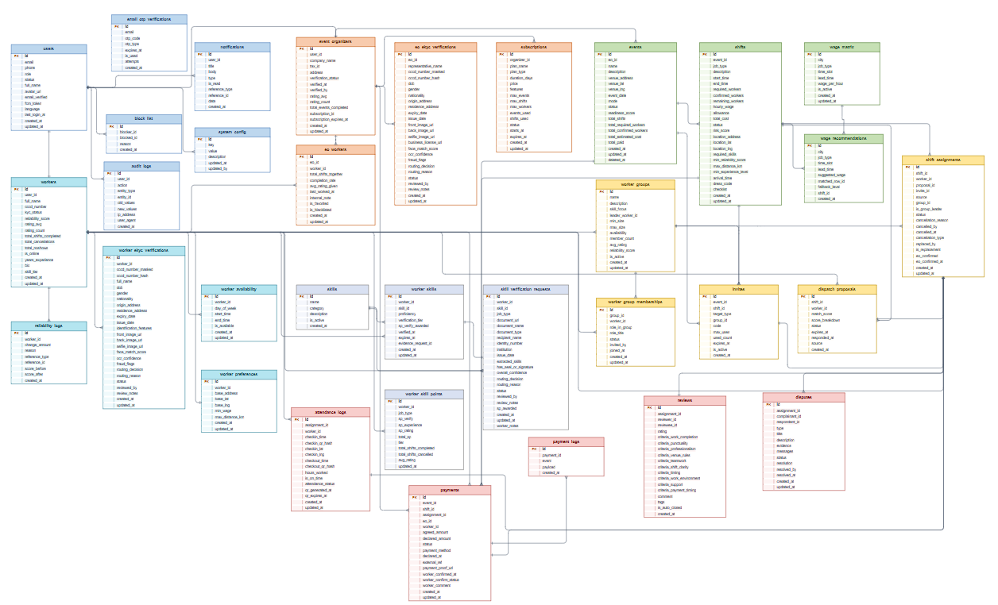

3.1 users
Column | Type | Constraints | Notes
id | UUID | PRIMARY KEY, DEFAULT gen_random_uuid() | Auto-increment
email | VARCHAR(255) | UNIQUE, NOT NULL | Login identifier; unique
phone | VARCHAR(20) | UNIQUE | Optional; E.164 format
password_hash | VARCHAR(255) |  | BCrypt hash; never store plaintext
role | USER_ROLE | NOT NULL | ADMIN, CSKH, EVENT_ORGANIZER, WORKER
status | USER_STATUS | DEFAULT 'PENDING_VERIFICATION' | ACTIVE / LOCKED / SUSPENDED / PENDING_VERIFICATION
full_name | VARCHAR(255) |  | Display name
avatar_url | TEXT |  | CDN URL
email_verified | BOOLEAN | DEFAULT FALSE | True after OTP confirm
email_otp | VARCHAR(10) |  | 6-digit code; sent via email
email_otp_expires_at | TIMESTAMPTZ |  | 5 min validity
password_reset_otp | VARCHAR(10) |  | 6-digit code; sent via email
password_reset_otp_expires_at | TIMESTAMPTZ |  | 10 min validity
failed_login_attempts | INT | DEFAULT 0 | Lock after 5
locked_until | TIMESTAMPTZ |  | Auto-unlock timestamp
fcm_token | TEXT |  | Push notification token
language | VARCHAR(5) | DEFAULT 'vi' | ISO 639-1 (vi, en)
last_login_at | TIMESTAMPTZ |  | Updated on successful login
created_at | TIMESTAMPTZ | DEFAULT NOW() | Row creation timestamp
updated_at | TIMESTAMPTZ | DEFAULT NOW() | Auto-updated via trigger

3.2 event_organizers
Column | Type | Constraints | Notes
id | UUID | PRIMARY KEY, DEFAULT gen_random_uuid() | Auto-increment
user_id | UUID | UNIQUE, NOT NULL, FK → users.id ON DELETE CASCADE | 1:1 with users; CASCADE delete
company_name | VARCHAR(255) | NOT NULL | Legal company name
tax_id | VARCHAR(20) |  | MST (mã số thuế)
address | TEXT |  | Registered business address
verification_status | VERIFICATION_STATUS | DEFAULT 'PENDING' | PENDING / APPROVED / REJECTED
verified_at | TIMESTAMPTZ |  | Timestamp of admin approval
verified_by | UUID | FK → users.id | Admin user id
rating_avg | DECIMAL(3,2) | DEFAULT 0 | 0.00 – 5.00; updated on new review
rating_count | INT | DEFAULT 0 | Total reviews received
total_events_completed | INT | DEFAULT 0 | Counter; recompute periodically
subscription_id | UUID |  | Reference to active subscription
subscription_expires_at | TIMESTAMPTZ |  | Mirrored from latest subscription
created_at | TIMESTAMPTZ | DEFAULT NOW() | Row creation timestamp
updated_at | TIMESTAMPTZ | DEFAULT NOW() | Auto-updated via trigger

3.3 workers
Column | Type | Constraints | Notes
id | UUID | PRIMARY KEY, DEFAULT gen_random_uuid() | Auto-increment
user_id | UUID | UNIQUE, NOT NULL, FK → users.id ON DELETE CASCADE | 1:1 with users; CASCADE delete
full_name | VARCHAR(255) | NOT NULL | As on CCCD
cccd_number | VARCHAR(12) |  | 12-digit Vietnamese ID
cccd_front_url | TEXT |  | OCR + face match source
cccd_back_url | TEXT |  | OCR source
selfie_url | TEXT |  | Liveness check source
kyc_status | KYC_STATUS | DEFAULT 'PENDING' | PENDING / APPROVED / REJECTED / SUSPICIOUS
kyc_submitted_at | TIMESTAMPTZ |  | When user finished KYC upload
kyc_reviewed_by | UUID | FK → users.id | Admin/CSKH user id
reliability_score | INT | DEFAULT 50, CHECK (reliability_score >= 0 AND reliability_score <= 100) | 0–100; default 50
rating_avg | DECIMAL(3,2) | DEFAULT 0 | 0.00 – 5.00
rating_count | INT | DEFAULT 0 | Total reviews received
total_shifts_completed | INT | DEFAULT 0 | Counter
total_cancellations | INT | DEFAULT 0 | Counter; used for reliability
total_noshows | INT | DEFAULT 0 | Counter; -25 RS each
is_online | BOOLEAN | DEFAULT FALSE | Toggled by worker app
base_address | TEXT |  | Default search origin
base_lat | DECIMAL(10,8) |  | WGS84
base_lng | DECIMAL(11,8) |  | WGS84
skills | UUID[] | DEFAULT '{}' | Array of skill ids
years_experience | INT | DEFAULT 0 | Self-reported
bio | TEXT |  | Worker profile description
min_wage | BIGINT | DEFAULT 0 | Floor for proposals (VND)
max_distance_km | DECIMAL(5,2) | DEFAULT 30 | Default 30
skill_tier | SKILL_TIER | DEFAULT 'STARTER' | STARTER → MASTER
created_at | TIMESTAMPTZ | DEFAULT NOW() | Row creation timestamp
updated_at | TIMESTAMPTZ | DEFAULT NOW() | Auto-updated via trigger

3.4 skills
Column | Type | Constraints | Notes
id | UUID | PRIMARY KEY, DEFAULT gen_random_uuid() | Auto-increment
name | VARCHAR(100) | NOT NULL | e.g. "Phục vụ bàn"
category | VARCHAR(100) |  | Phục vụ / Bán hàng / Kỹ thuật
description | TEXT |  | Optional
is_active | BOOLEAN | DEFAULT TRUE | Soft delete flag
created_at | TIMESTAMPTZ | DEFAULT NOW() | Row creation timestamp

3.5 worker_availability
Column | Type | Constraints | Notes
id | UUID | PRIMARY KEY, DEFAULT gen_random_uuid() | Auto-increment
worker_id | UUID | NOT NULL, FK → workers.id ON DELETE CASCADE | CASCADE delete
day_of_week | INT | CHECK (day_of_week >= 0 AND day_of_week <= 6) | 0=Sunday … 6=Saturday
start_time | TIME |  | Local time
end_time | TIME |  | Local time
is_available | BOOLEAN | DEFAULT TRUE | Toggle without delete
created_at | TIMESTAMPTZ | DEFAULT NOW() | Row creation timestamp
updated_at | TIMESTAMPTZ | DEFAULT NOW() | Auto-updated via trigger

3.6 events
Column | Type | Constraints | Notes
id | UUID | PRIMARY KEY, DEFAULT gen_random_uuid() | Auto-increment
organizer_id | UUID | NOT NULL, FK → event_organizers.id ON DELETE CASCADE | CASCADE delete
name | VARCHAR(255) | NOT NULL | Event title
description | TEXT |  | Optional
venue_address | TEXT | NOT NULL | Required even in Invite mode
venue_lat | DECIMAL(10,8) |  | WGS84
venue_lng | DECIMAL(11,8) |  | WGS84
event_date | DATE | NOT NULL | Single date (multi-day split into shifts)
mode | EVENT_MODE | NOT NULL | MATCHING (auto) / INVITE (manual)
status | EVENT_STATUS | DEFAULT 'DRAFT' | DRAFT → ACTIVE → ONGOING → COMPLETED
readiness_score | INT | DEFAULT 0 | 0–100; used to gate Matching activation
total_shifts | INT | DEFAULT 0 | Denormalized counter
total_required_workers | INT | DEFAULT 0 | Denormalized counter
total_confirmed_workers | INT | DEFAULT 0 | Denormalized counter
total_estimated_cost | BIGINT |  | VND
total_paid | BIGINT | DEFAULT 0 | VND
created_at | TIMESTAMPTZ | DEFAULT NOW() | Row creation timestamp
updated_at | TIMESTAMPTZ | DEFAULT NOW() | Auto-updated via trigger
deleted_at | TIMESTAMPTZ |  | Soft delete

3.7 shifts
Column | Type | Constraints | Notes
id | UUID | PRIMARY KEY, DEFAULT gen_random_uuid() | Auto-increment
event_id | UUID | NOT NULL, FK → events.id ON DELETE CASCADE | CASCADE delete
job_type | VARCHAR(100) | NOT NULL | e.g. "PG", "Lễ tân"
description | TEXT |  | Optional
start_time | TIMESTAMPTZ | NOT NULL | UTC; displayed in local TZ
end_time | TIMESTAMPTZ | NOT NULL | UTC
required_workers | INT | NOT NULL, DEFAULT 1 | Headcount needed
confirmed_workers | INT | DEFAULT 0 | After assignment confirm
remaining_workers | INT | DEFAULT 0 | = required - confirmed
hourly_wage | BIGINT | NOT NULL | VND; from wage_matrix recommendation
allowance | BIGINT | DEFAULT 0 | VND; bonus/meal/transport
total_cost | BIGINT |  | = (hourly_wage × hours) × required_workers + allowance
status | SHIFT_STATUS | DEFAULT 'DRAFT' | DRAFT → ACTIVE → FULLY_STAFFED → IN_PROGRESS → COMPLETED
risk_score | DECIMAL(5,2) | DEFAULT 0 | 0–100; high = low fill probability
location_address | TEXT |  | Optional; defaults from event
location_lat | DECIMAL(10,8) |  | WGS84
location_lng | DECIMAL(11,8) |  | WGS84
required_skills | UUID[] | DEFAULT '{}' | Array of skill ids
min_reliability_score | INT | DEFAULT 0 | Filter for matching engine
max_distance_km | DECIMAL(5,2) | DEFAULT 30 | Default 30
min_experience_level | EXPERIENCE_LEVEL |  | BEGINNER / INTERMEDIATE / ADVANCED
arrival_time | TIME |  | When worker should arrive (not start)
dress_code | TEXT |  | Free text
checklist | JSONB | DEFAULT '[]' | JSONB; per-shift items
created_at | TIMESTAMPTZ | DEFAULT NOW() | Row creation timestamp
updated_at | TIMESTAMPTZ | DEFAULT NOW() | Auto-updated via trigger

3.8 invites
Column | Type | Constraints | Notes
id | UUID | PRIMARY KEY, DEFAULT gen_random_uuid() | Auto-increment
event_id | UUID | NOT NULL, FK → events.id ON DELETE CASCADE | CASCADE delete
shift_id | UUID | FK → shifts.id ON DELETE SET NULL | NULL for group invite
target_type | VARCHAR(20) | DEFAULT 'SHIFT', CHECK (target_type IN ('SHIFT', 'GROUP') | SHIFT (single) / GROUP (group invite)
group_id | UUID |  | Set when target_type=GROUP
code | VARCHAR(10) | NOT NULL | Short shareable code
max_uses | INT | DEFAULT 1 | 1 for single, N for group
used_count | INT | DEFAULT 0 | Increment on accept
expires_at | TIMESTAMPTZ | NOT NULL | Default 24h
is_active | BOOLEAN | DEFAULT TRUE | Soft disable
created_at | TIMESTAMPTZ | DEFAULT NOW() | Row creation timestamp

3.9 dispatch_proposals
Column | Type | Constraints | Notes
id | UUID | PRIMARY KEY, DEFAULT gen_random_uuid() | Auto-increment
shift_id | UUID | NOT NULL, FK → shifts.id ON DELETE CASCADE | CASCADE delete
worker_id | UUID | NOT NULL, FK → workers.id ON DELETE CASCADE | CASCADE delete
match_score | DECIMAL(5,2) |  | 0–100 from matching engine
score_breakdown | JSONB |  | JSONB; per-factor scores
status | PROPOSAL_STATUS | DEFAULT 'PENDING' | PENDING / ACCEPTED / REJECTED / EXPIRED
expires_at | TIMESTAMPTZ | NOT NULL | Default 15 min
responded_at | TIMESTAMPTZ |  | Set on accept/reject
source | VARCHAR(20) | DEFAULT 'MATCHING', CHECK (source IN ('MATCHING', 'DIRECT', 'BULK') | MATCHING / DIRECT / BULK
created_at | TIMESTAMPTZ | DEFAULT NOW() | Row creation timestamp

3.10 shift_assignments
Column | Type | Constraints | Notes
id | UUID | PRIMARY KEY, DEFAULT gen_random_uuid() | Auto-increment
shift_id | UUID | NOT NULL, FK → shifts.id ON DELETE CASCADE | CASCADE delete
worker_id | UUID | NOT NULL, FK → workers.id ON DELETE CASCADE | CASCADE delete
proposal_id | UUID | FK → dispatch_proposals.id ON DELETE SET NULL | NULL if from invite
invite_id | UUID | FK → invites.id ON DELETE SET NULL | NULL if from proposal
source | VARCHAR(20) | CHECK (source IN ('MATCHING', 'DIRECT', 'BULK', 'GROUP') | MATCHING / DIRECT / BULK / GROUP
group_id | UUID |  | Set when source=GROUP
is_group_leader | BOOLEAN | DEFAULT FALSE | True for the inviter
status | ASSIGNMENT_STATUS | DEFAULT 'CONFIRMED' | PENDING → CONFIRMED → CHECKED_IN → COMPLETED
cancellation_reason | TEXT |  | Free text
cancelled_by | UUID | FK → users.id | User id who cancelled
cancelled_at | TIMESTAMPTZ |  | Timestamp
cancellation_type | VARCHAR(20) |  | WORKER / EO / NO_SHOW / SYSTEM
replaced_by | UUID | FK → shift_assignments.id | Self-FK to replacement assignment
is_replacement | BOOLEAN | DEFAULT FALSE | True if this fills a cancelled slot
eo_confirmed | BOOLEAN | DEFAULT FALSE | EO marks "đã xong" after review
eo_confirmed_at | TIMESTAMPTZ |  | Timestamp
created_at | TIMESTAMPTZ | DEFAULT NOW() | Row creation timestamp
updated_at | TIMESTAMPTZ | DEFAULT NOW() | Auto-updated via trigger

3.11 attendance_logs
Column | Type | Constraints | Notes
id | UUID | PRIMARY KEY, DEFAULT gen_random_uuid() | Auto-increment
assignment_id | UUID | UNIQUE, NOT NULL, FK → shift_assignments.id ON DELETE CASCADE | UNIQUE 1:1
worker_id | UUID | NOT NULL, FK → workers.id ON DELETE CASCADE | Denormalized for query speed
checkin_time | TIMESTAMPTZ |  | Timestamp
checkin_qr_hash | VARCHAR(64) |  | HMAC of QR payload
checkin_lat | DECIMAL(10,8) |  | WGS84
checkin_lng | DECIMAL(11,8) |  | WGS84
checkout_time | TIMESTAMPTZ |  | Timestamp
checkout_qr_hash | VARCHAR(64) |  | HMAC of QR payload
hours_worked | DECIMAL(5,2) |  | = checkout - checkin
is_on_time | BOOLEAN |  | True if checkin ≤ arrival_time
attendance_status | ATTENDANCE_STATUS | DEFAULT 'NOT_CHECKED_IN' | NOT_CHECKED_IN / ON_TIME / LATE / CHECKED_OUT / NO_SHOW
qr_generated_at | TIMESTAMPTZ |  | For QR rotation
qr_expires_at | TIMESTAMPTZ |  | Default 30s
created_at | TIMESTAMPTZ | DEFAULT NOW() | Row creation timestamp
updated_at | TIMESTAMPTZ | DEFAULT NOW() | Auto-updated via trigger

3.12 disputes
Column | Type | Constraints | Notes
id | UUID | PRIMARY KEY, DEFAULT gen_random_uuid() | Auto-increment
assignment_id | UUID | FK → shift_assignments.id ON DELETE SET NULL | NULL allowed (e.g. conduct)
complainant_id | UUID | NOT NULL, FK → users.id | User who raised
respondent_id | UUID | NOT NULL, FK → users.id | User complained about
type | DISPUTE_TYPE | NOT NULL | PAYMENT / CONDUCT / OVERTIME / SCOPE / APPEAL
title | VARCHAR(255) |  | Short summary
description | TEXT | NOT NULL | Full text
evidence | JSONB | DEFAULT '[]' | JSONB array of URLs
messages | JSONB | DEFAULT '[]' | JSONB chat thread
status | DISPUTE_STATUS | DEFAULT 'SUBMITTED' | SUBMITTED → IN_REVIEW → RESOLVED / ESCALATED
resolution | TEXT |  | Admin note
resolved_by | UUID | FK → users.id | Admin/CSKH id
resolved_at | TIMESTAMPTZ |  | Timestamp
created_at | TIMESTAMPTZ | DEFAULT NOW() | Row creation timestamp
updated_at | TIMESTAMPTZ | DEFAULT NOW() | Auto-updated via trigger

3.13 reviews

Column | Type | Constraints | Notes
id | UUID | PRIMARY KEY, DEFAULT gen_random_uuid() | Auto-increment
assignment_id | UUID | NOT NULL, FK → shift_assignments.id ON DELETE CASCADE | CASCADE delete
reviewer_id | UUID | NOT NULL, FK → users.id | Who writes the review
reviewee_id | UUID | NOT NULL, FK → users.id | Who is reviewed
rating | INT | NOT NULL, CHECK (rating >= 1 AND rating <= 5) | 1–5
criteria_work_completion | DECIMAL(3,2) |  | For worker by EO
criteria_punctuality | DECIMAL(3,2) |  | For worker by EO
criteria_professionalism | DECIMAL(3,2) |  | For worker by EO
criteria_venue_rules | DECIMAL(3,2) |  | For worker by EO
criteria_teamwork | DECIMAL(3,2) |  | For worker by EO
criteria_shift_clarity | DECIMAL(3,2) |  | For EO by worker
criteria_timing | DECIMAL(3,2) |  | For EO by worker
criteria_work_environment | DECIMAL(3,2) |  | For EO by worker
criteria_support | DECIMAL(3,2) |  | For EO by worker
criteria_payment_timing | DECIMAL(3,2) |  | For EO by worker
comment | TEXT |  | Free text
tags | TEXT[] | DEFAULT '{}' | Array of short tags
is_auto_closed | BOOLEAN | DEFAULT FALSE | True if 7-day window passed
created_at | TIMESTAMPTZ | DEFAULT NOW() | Row creation timestamp

3.14 reliability_logs
Column | Type | Constraints | Notes
id | UUID | PRIMARY KEY, DEFAULT gen_random_uuid() | Auto-increment
worker_id | UUID | NOT NULL, FK → workers.id ON DELETE CASCADE | CASCADE delete
change_amount | INT | NOT NULL | +/- integer
reason | VARCHAR(255) | NOT NULL | e.g. "Completed shift" / "No-show"
reference_type | VARCHAR(50) |  | SHIFT / DISPUTE / ADMIN
reference_id | UUID |  | Source entity id
score_before | INT |  | Snapshot
score_after | INT |  | Snapshot
created_at | TIMESTAMPTZ | DEFAULT NOW() | Row creation timestamp

3.15 payments
Column | Type | Constraints | Notes
id | UUID | PRIMARY KEY, DEFAULT gen_random_uuid() | Auto-increment
event_id | UUID | FK → events.id ON DELETE SET NULL | Optional FK
shift_id | UUID | FK → shifts.id ON DELETE SET NULL | Optional FK
assignment_id | UUID | FK → shift_assignments.id ON DELETE SET NULL | 1:1 per shift or per group
eo_id | UUID | FK → event_organizers.id | Payer
worker_id | UUID | FK → workers.id | Payee
agreed_amount | BIGINT | NOT NULL | From shift.total_cost
declared_amount | BIGINT |  | What EO says they paid
status | PAYMENT_STATUS | DEFAULT 'NOT_DECLARED' | NOT_DECLARED → DECLARED_PENDING_WORKER → CONFIRMED_* / DISPUTED / UNVERIFIED
payment_method | VARCHAR(50) |  | CASH / BANK / MOMO / VNPAY
declared_at | TIMESTAMPTZ |  | When EO marked paid
external_ref | VARCHAR(100) |  | Bank transaction ref
payment_proof_url | TEXT |  | Image of transfer
worker_confirmed_at | TIMESTAMPTZ |  | When worker confirmed
worker_confirm_status | VARCHAR(20) | CHECK (worker_confirm_status IN ('CONFIRMED_FULL', 'CONFIRMED_PARTIAL', 'REJECTED') | CONFIRMED_FULL / CONFIRMED_PARTIAL / REJECTED
worker_comment | TEXT |  | Optional
created_at | TIMESTAMPTZ | DEFAULT NOW() | Row creation timestamp
updated_at | TIMESTAMPTZ | DEFAULT NOW() | Auto-updated via trigger

3.16 payment_logs
Column | Type | Constraints | Notes
id | BIGSERIAL | PRIMARY KEY | BIGSERIAL
payment_id | UUID | FK → payments.id ON DELETE CASCADE | CASCADE delete
event | TEXT |  | CREATED / DECLARED / CONFIRMED / DISPUTED
payload | JSONB |  | JSONB; full state snapshot
created_at | TIMESTAMPTZ | DEFAULT NOW() | Row creation timestamp

3.17 subscriptions
Column | Type | Constraints | Notes
id | UUID | PRIMARY KEY, DEFAULT gen_random_uuid() | Auto-increment
organizer_id | UUID | NOT NULL, FK → event_organizers.id | FK to event_organizers
plan_name | VARCHAR(100) |  | Display name
plan_type | SUBSCRIPTION_PLAN | DEFAULT 'INVITE_ONLY' | INVITE_ONLY / MATCHING_PLUS
duration_days | INT |  | e.g. 30 / 90 / 365
price | BIGINT | NOT NULL | VND; paid via VNPay
features | JSONB | DEFAULT '[]' | JSONB array of feature flags
max_events | INT |  | Quota; NULL = unlimited
max_shifts | INT |  | Quota
max_workers | INT |  | Quota
events_used | INT | DEFAULT 0 | Counter
shifts_used | INT | DEFAULT 0 | Counter
status | SUBSCRIPTION_STATUS | DEFAULT 'ACTIVE' | ACTIVE / EXPIRED / CANCELLED
starts_at | TIMESTAMPTZ |  | When payment confirmed
expires_at | TIMESTAMPTZ |  | starts_at + duration
created_at | TIMESTAMPTZ | DEFAULT NOW() | Row creation timestamp
updated_at | TIMESTAMPTZ | DEFAULT NOW() | Auto-updated via trigger

3.18 worker_groups
Column | Type | Constraints | Notes
id | UUID | PRIMARY KEY, DEFAULT gen_random_uuid() | Auto-increment
name | VARCHAR(100) | NOT NULL | Group display name
description | TEXT |  | Optional
skill_focus | VARCHAR(100) |  | Primary job type
leader_worker_id | UUID | NOT NULL, FK → workers.id | Creator; LEADER role
min_size | INT | DEFAULT 5 | Default 5
max_size | INT | DEFAULT 20 | Default 20
availability | JSONB | DEFAULT '{}' | JSONB aggregated schedule
member_count | INT | DEFAULT 0 | Denormalized counter
avg_rating | DECIMAL(3,2) | DEFAULT 0 | Denormalized
reliability_score | INT | DEFAULT 50 | Denormalized
is_active | BOOLEAN | DEFAULT TRUE | False when dissolved
created_at | TIMESTAMPTZ | DEFAULT NOW() | Row creation timestamp
updated_at | TIMESTAMPTZ | DEFAULT NOW() | Auto-updated via trigger

3.19 worker_group_memberships
Column | Type | Constraints | Notes
id | UUID | PRIMARY KEY, DEFAULT gen_random_uuid() | Auto-increment
group_id | UUID | NOT NULL, FK → worker_groups.id ON DELETE CASCADE | CASCADE delete
worker_id | UUID | NOT NULL, FK → workers.id ON DELETE CASCADE | CASCADE delete
role_in_group | GROUP_MEMBER_ROLE | DEFAULT 'MEMBER' | LEADER / MEMBER
role_title | VARCHAR(50) |  | e.g. "Phó nhóm"
status | GROUP_MEMBERSHIP_STATUS | DEFAULT 'PENDING' | PENDING / ACTIVE / REMOVED
invited_by | UUID | FK → workers.id | Worker id who invited
joined_at | TIMESTAMPTZ |  | When status → ACTIVE
created_at | TIMESTAMPTZ | DEFAULT NOW() | Row creation timestamp
updated_at | TIMESTAMPTZ | DEFAULT NOW() | Auto-updated via trigger

3.20 wage_matrix
Column | Type | Constraints | Notes
id | UUID | PRIMARY KEY, DEFAULT gen_random_uuid() | Auto-increment
city | CITY | NOT NULL | TP.HCM / HANOI / DANANG
job_type | VARCHAR(100) | NOT NULL | e.g. "PG"
time_slot | TIME_SLOT | NOT NULL | DAYTIME_WEEKDAY / EVENING_WEEKDAY / NIGHT_WEEKDAY / DAYTIME_WEEKEND / EVENING_WEEKEND
lead_time | LEAD_TIME | NOT NULL | STANDARD / SOON / URGENT
wage_per_hour | BIGINT | NOT NULL | VND
is_active | BOOLEAN | DEFAULT TRUE | Soft toggle
created_at | TIMESTAMPTZ | DEFAULT NOW() | Row creation timestamp
updated_at | TIMESTAMPTZ | DEFAULT NOW() | Auto-updated via trigger

3.21 wage_recommendations
Column | Type | Constraints | Notes
id | UUID | PRIMARY KEY, DEFAULT gen_random_uuid() | Auto-increment
city | CITY |  | NULL if not matched
job_type | VARCHAR(100) |  | NULL if not matched
time_slot | TIME_SLOT |  | NULL if not matched
lead_time | LEAD_TIME |  | NULL if not matched
suggested_wage | BIGINT |  | VND
matched_row_id | UUID | FK → wage_matrix.id | FK to wage_matrix
fallback_level | INT | DEFAULT 0, CHECK (fallback_level >= 0 AND fallback_level <= 3) | 0=exact, 1=drop time_slot, 2=drop lead_time, 3=use default
shift_id | UUID | FK → shifts.id | Which shift this was for
created_at | TIMESTAMPTZ | DEFAULT NOW() | Row creation timestamp

3.22 worker_skill_points
Column | Type | Constraints | Notes
id | UUID | PRIMARY KEY, DEFAULT gen_random_uuid() | Auto-increment
worker_id | UUID | NOT NULL, FK → workers.id ON DELETE CASCADE | CASCADE delete
job_type | VARCHAR(100) |  | Per-role skill tracking
sp_verify | INT | DEFAULT 0 | Points from KYC/skill test
sp_experience | INT | DEFAULT 0 | Points from years_experience
sp_rating | INT | DEFAULT 0 | Points from avg rating
total_sp | INT | DEFAULT 0 | = sp_verify + sp_experience + sp_rating
tier | SKILL_TIER | DEFAULT 'STARTER' | Computed from total_sp
total_shifts_completed | INT | DEFAULT 0 | Counter
total_shifts_cancelled | INT | DEFAULT 0 | Counter
avg_rating | DECIMAL(3,2) | DEFAULT 0 | Per job type
updated_at | TIMESTAMPTZ | DEFAULT NOW() | Auto-updated via trigger

3.23 eo_workers
Column | Type | Constraints | Notes
id | UUID | PRIMARY KEY, DEFAULT gen_random_uuid() | Auto-increment
eo_id | UUID | NOT NULL, FK → event_organizers.id ON DELETE CASCADE | CASCADE delete
worker_id | UUID | NOT NULL, FK → workers.id ON DELETE CASCADE | CASCADE delete
total_shifts_together | INT | DEFAULT 0 | Counter
completion_rate | DECIMAL(5,2) | DEFAULT 0 | 0–100%
avg_rating_given | DECIMAL(3,2) | DEFAULT 0 | EO's avg rating to this worker
last_worked_at | TIMESTAMPTZ |  | Timestamp
internal_note | TEXT |  | EO's private memo
is_favorited | BOOLEAN | DEFAULT FALSE | Star flag
is_blacklisted | BOOLEAN | DEFAULT FALSE | Block from re-invite
created_at | TIMESTAMPTZ | DEFAULT NOW() | Row creation timestamp
updated_at | TIMESTAMPTZ | DEFAULT NOW() | Auto-updated via trigger

3.24 notifications
Column | Type | Constraints | Notes
id | UUID | PRIMARY KEY, DEFAULT gen_random_uuid() | Auto-increment
user_id | UUID | NOT NULL, FK → users.id ON DELETE CASCADE | CASCADE delete
title | VARCHAR(255) | NOT NULL | Short title
body | TEXT |  | Full message
type | NOTIF_TYPE | NOT NULL | PROPOSAL / ASSIGNMENT / REMINDER / PAYMENT / DISPUTE / RATING / SYSTEM / GROUP
is_read | BOOLEAN | DEFAULT FALSE | Toggle on view
reference_type | VARCHAR(50) |  | Entity type
reference_id | UUID |  | Entity id
data | JSONB |  | JSONB; navigation payload
created_at | TIMESTAMPTZ | DEFAULT NOW() | Row creation timestamp

3.25 block_list
Column | Type | Constraints | Notes
id | UUID | PRIMARY KEY, DEFAULT gen_random_uuid() | Auto-increment
blocker_id | UUID | NOT NULL, FK → users.id ON DELETE CASCADE | CASCADE delete
blocked_id | UUID | NOT NULL, FK → users.id ON DELETE CASCADE | CASCADE delete
reason | TEXT |  | Optional
created_at | TIMESTAMPTZ | DEFAULT NOW() | Row creation timestamp

3.26 system_config
Column | Type | Constraints | Notes
id | UUID | PRIMARY KEY, DEFAULT gen_random_uuid() | Auto-increment
key | VARCHAR(100) | UNIQUE, NOT NULL | Config key (UK)
value | TEXT |  | String value
description | TEXT |  | Human-readable
updated_at | TIMESTAMPTZ | DEFAULT NOW() | Auto-updated via trigger
updated_by | UUID | FK → users.id | Admin user id

3.27 audit_logs
Column | Type | Constraints | Notes
id | UUID | PRIMARY KEY, DEFAULT gen_random_uuid() | Auto-increment
user_id | UUID | FK → users.id | Actor (NULL for system)
action | VARCHAR(100) | NOT NULL | CREATE / UPDATE / DELETE / LOGIN / ...
entity_type | VARCHAR(50) |  | Table name
entity_id | UUID |  | Row id
old_values | JSONB |  | JSONB before state
new_values | JSONB |  | JSONB after state
ip_address | VARCHAR(45) |  | IPv4/IPv6
user_agent | TEXT |  | Browser/app
created_at | TIMESTAMPTZ | DEFAULT NOW() | Row creation timestamp

3.28 skill_verification_requests
Column | Type | Constraints | Notes
id | UUID | NOT NULL, PRIMARY KEY | DEFAULT gen_random_uuid()
worker_id | UUID | NOT NULL, FK | FK -> workers(id)
skill_id | UUID | FK | FK -> skills(id)
job_type | VARCHAR
document_url | TEXT
document_name | VARCHAR
document_type | VARCHAR
recipient_name | VARCHAR
identity_number | VARCHAR
institution | VARCHAR
issue_date | VARCHAR
extracted_skills | JSONB
has_seal_or_signature | BOOLEAN |  | DEFAULT false
overall_confidence | NUMERIC |  | DEFAULT 0.00
routing_decision | VARCHAR | NOT NULL
routing_reason | TEXT
status | VARCHAR | NOT NULL | DEFAULT 'PENDING_REVIEW' varying
reviewed_by | UUID | FK | FK -> users(id)
review_notes | TEXT
sp_awarded | INTEGER |  | DEFAULT 0
created_at | TIMESTAMPTZ |  | DEFAULT CURRENT_TIMESTAMP
updated_at | TIMESTAMPTZ |  | DEFAULT CURRENT_TIMESTAMP
worker_notes | TEXT

3.29 worker_skills
Column | Type | Constraints | Notes
id | UUID | NOT NULL, PRIMARY KEY | DEFAULT gen_random_uuid()
worker_id | UUID | NOT NULL, FK | FK -> workers(id)
skill_id | UUID | NOT NULL, FK | FK -> skills(id)
proficiency | ENUM (experience_level) | NOT NULL | DEFAULT 'BEGINNER'
verification_tier | VARCHAR | NOT NULL | DEFAULT 'SELF_DECLARED' varying CHECK (verification_tier = ANY (ARRAY['SELF_DECLARED' varying; CHECK: verification_tier::text = ANY (ARRAY['SELF_DECLARED'::character varying, 'AI_DOCUMENT'::character varying, 'PLATFORM_PROVEN'::character varying]::text[]
sp_verify_awarded | INTEGER | NOT NULL | DEFAULT 0 CHECK (sp_verify_awarded >= 0); CHECK: sp_verify_awarded >= 0
verified_at | TIMESTAMPTZ
expires_at | TIMESTAMPTZ
evidence_request_id | UUID | FK | FK -> skill_verification_requests(id)
created_at | TIMESTAMPTZ |  | DEFAULT CURRENT_TIMESTAMP
updated_at | TIMESTAMPTZ |  | DEFAULT CURRENT_TIMESTAMP

3.30 worker_preferences
Column | Type | Constraints | Notes
id | UUID | NOT NULL, PRIMARY KEY | DEFAULT gen_random_uuid()
worker_id | UUID | NOT NULL, UNIQUE, FK | FK -> workers(id)
base_address | TEXT
base_lat | DOUBLE PRECISION
base_lng | DOUBLE PRECISION
min_wage | NUMERIC |  | DEFAULT 0
max_distance_km | DOUBLE PRECISION |  | DEFAULT 20.0
created_at | TIMESTAMPTZ |  | DEFAULT CURRENT_TIMESTAMP
updated_at | TIMESTAMPTZ |  | DEFAULT CURRENT_TIMESTAMP

3.31 eo_ekyc_verifications
Column | Type | Constraints | Notes
id | UUID | NOT NULL, PRIMARY KEY | DEFAULT gen_random_uuid()
eo_id | UUID | NOT NULL, FK | FK -> event_organizers(id)
representative_name | VARCHAR
cccd_number_masked | VARCHAR
cccd_number_hash | VARCHAR
dob | VARCHAR
gender | VARCHAR
nationality | VARCHAR |  | DEFAULT 'Việt Nam' varying
origin_address | TEXT
residence_address | TEXT
expiry_date | VARCHAR
issue_date | VARCHAR
front_image_url | TEXT
back_image_url | TEXT
selfie_image_url | TEXT
business_license_url | TEXT
face_match_score | NUMERIC |  | DEFAULT 0.00
ocr_confidence | NUMERIC |  | DEFAULT 0.00
fraud_flags | JSONB
routing_decision | VARCHAR | NOT NULL | DEFAULT 'MANUAL_REVIEW' varying
routing_reason | TEXT
status | VARCHAR | NOT NULL | DEFAULT 'PENDING_REVIEW' varying
reviewed_by | UUID | FK | FK -> users(id)
review_notes | TEXT
created_at | TIMESTAMPTZ |  | DEFAULT CURRENT_TIMESTAMP
updated_at | TIMESTAMPTZ |  | DEFAULT CURRENT_TIMESTAMP

3.32 email_otp_verifications
Column | Type | Constraints | Notes
id | UUID | NOT NULL, PRIMARY KEY | DEFAULT gen_random_uuid()
email | VARCHAR | NOT NULL
otp_code | VARCHAR | NOT NULL
otp_type | VARCHAR | NOT NULL | DEFAULT 'REGISTER' varying
expires_at | TIMESTAMPTZ | NOT NULL
is_used | BOOLEAN |  | DEFAULT false
attempts | INTEGER |  | DEFAULT 0
created_at | TIMESTAMPTZ |  | DEFAULT CURRENT_TIMESTAMP

3.33 worker_ekyc_verifications
Column | Type | Constraints | Notes
id | UUID | NOT NULL, PRIMARY KEY | DEFAULT gen_random_uuid()
worker_id | UUID | NOT NULL, FK | FK -> workers(id)
cccd_number_masked | VARCHAR
cccd_number_hash | VARCHAR
full_name | VARCHAR
dob | VARCHAR
gender | VARCHAR
nationality | VARCHAR |  | DEFAULT 'Việt Nam' varying
origin_address | TEXT
residence_address | TEXT
expiry_date | VARCHAR
issue_date | VARCHAR
identification_features | TEXT
front_image_url | TEXT
back_image_url | TEXT
selfie_image_url | TEXT
face_match_score | NUMERIC |  | DEFAULT 0.00
ocr_confidence | NUMERIC |  | DEFAULT 0.00
fraud_flags | JSONB
routing_decision | VARCHAR | NOT NULL
routing_reason | TEXT
status | VARCHAR | NOT NULL | DEFAULT 'PENDING_REVIEW' varying
reviewed_by | UUID | FK | FK -> users(id)
review_notes | TEXT
created_at | TIMESTAMPTZ |  | DEFAULT CURRENT_TIMESTAMP
updated_at | TIMESTAMPTZ |  | DEFAULT CURRENT_TIMESTAMP

II. Detailed Code Design

1. Workforce Preparation, Matching & Assignment (FE-02 to FE-08)

1.1 Class Diagrams
The workforce preparation and allocation domain is decomposed into three cohesive class diagrams adopting Clean Architecture (Controller - Service - Repository - Entity):
1.1.1 Event, Shift & Wage Matrix Management (CD-01)
Figure 1.1: UML Class Diagram for Event, Shift & Wage Matrix Management
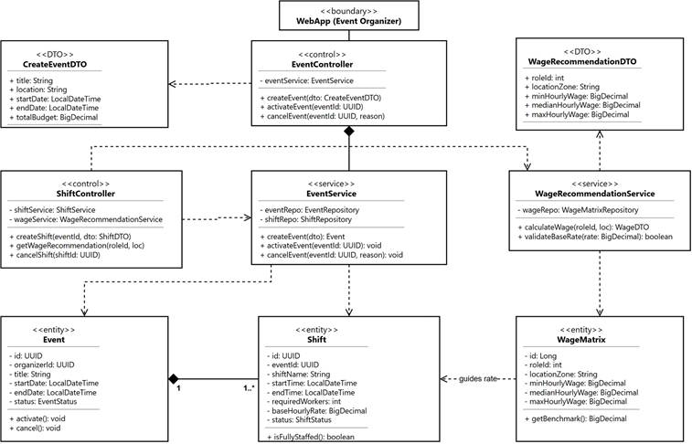
1.1.2 Worker Profile, Skill Point & Verification Management (CD-02)
Figure 1.2: UML Class Diagram for Worker Profile, Skill Point & Verification Management
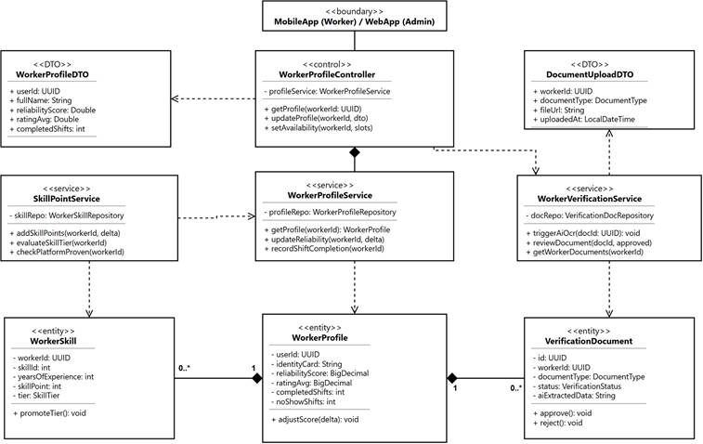
1.1.3 Shift Matching, Dispatch, Assignment & Team Management (CD-03)
Figure 1.3: UML Class Diagram for Shift Matching, Dispatch, Assignment & Team Management
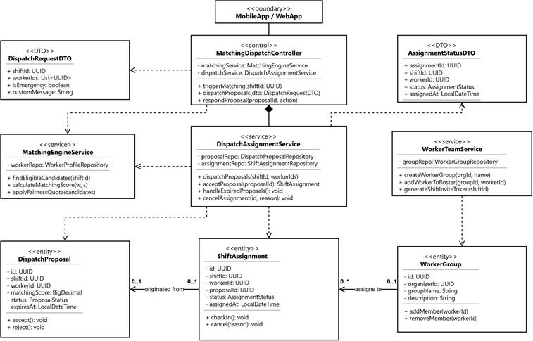

1.2 Sequence Diagrams
This section captures the sequence interaction flows across the 13 specified workflows (SD-01 to SD-13) for workforce preparation, candidate matching, proposal dispatching, and team rostering according to Category specifications.
1.2.1 Event Creation, Shift Setup & Wage Recommendation (SD-01)
This sequence captures the Event Organizer selecting a shift role and location, fetching benchmark wage recommendations via WageService, and persisting the event along with configured shifts in DRAFT status.
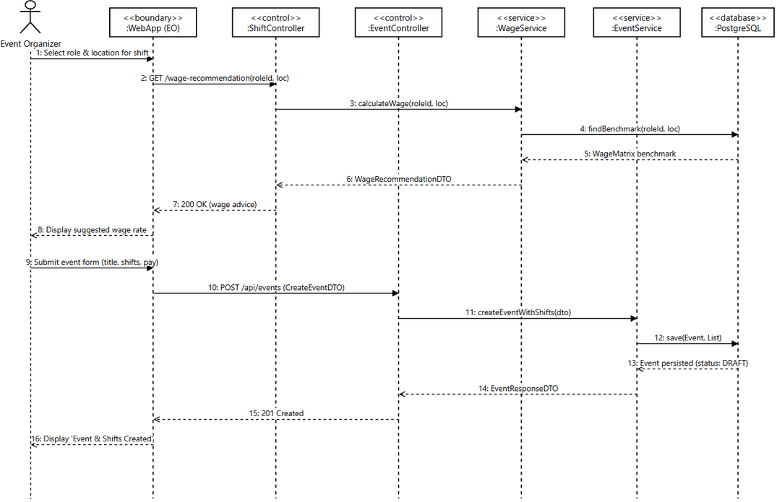
Figure 1.4: Sequence Diagram for Event Creation, Shift Setup & Wage Recommendation

1.2.2 Event Activation (SD-02)
This sequence illustrates the activation workflow where EventService validates that the event contains at least one active shift before transitioning status to ACTIVE and notifying relevant subsystems.
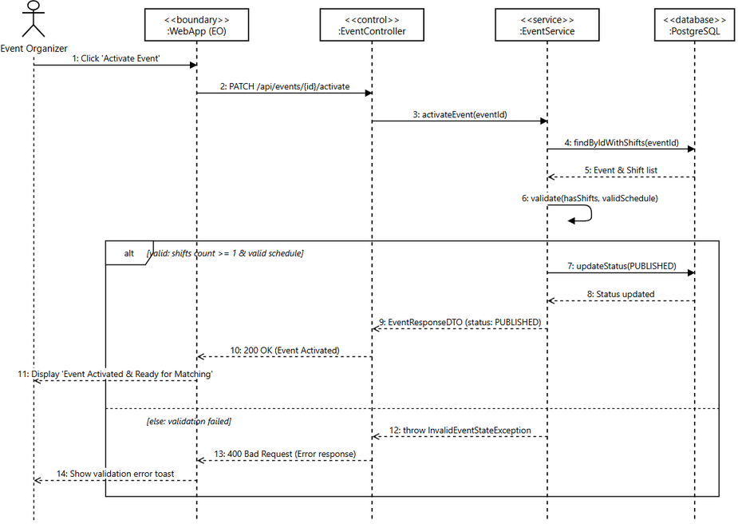
Figure 1.5: Sequence Diagram for Event Activation

1.2.3 Event & Shift Cancellation (SD-03)
This sequence details the cancellation process where ShiftService marks shifts as CANCELLED, releases confirmed worker calendar locks, and triggers automated push notifications to affected workers.
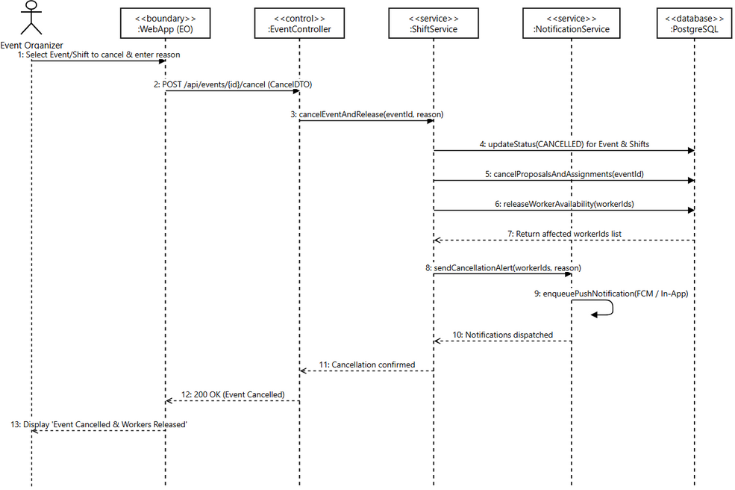
Figure 1.6: Sequence Diagram for Event & Shift Cancellation

1.2.4 Worker Profile, Skill & Availability Update (SD-04)
This sequence demonstrates a worker updating profile details, skill sets, years of experience, and recurring weekly availability slots through the mobile application.
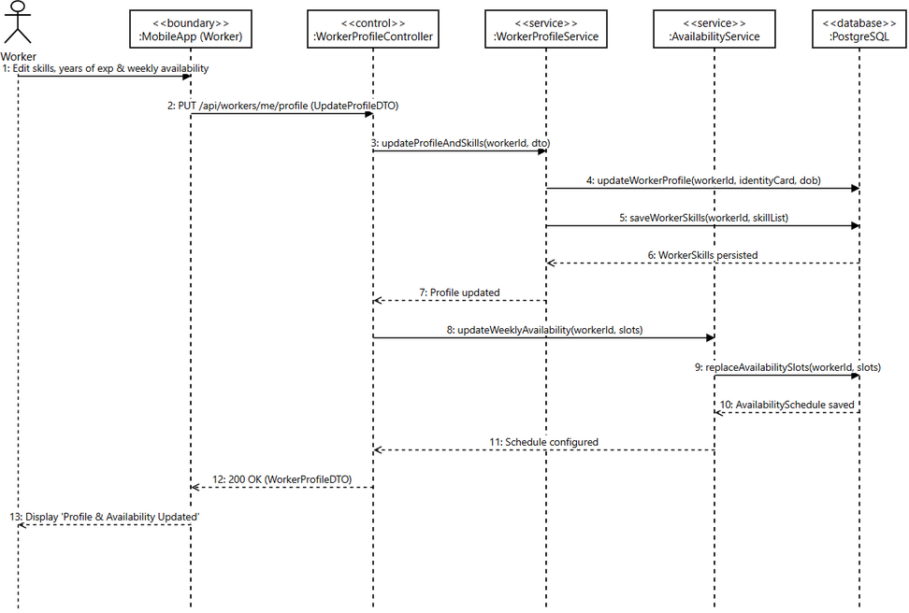
Figure 1.7: Sequence Diagram for Worker Profile, Skill & Availability Update

1.2.5 Identity & Certification Document Verification (SD-05)
This sequence describes identity document verification incorporating AI OCR analysis for text extraction and fraud detection, followed by administrative manual review and status approval.
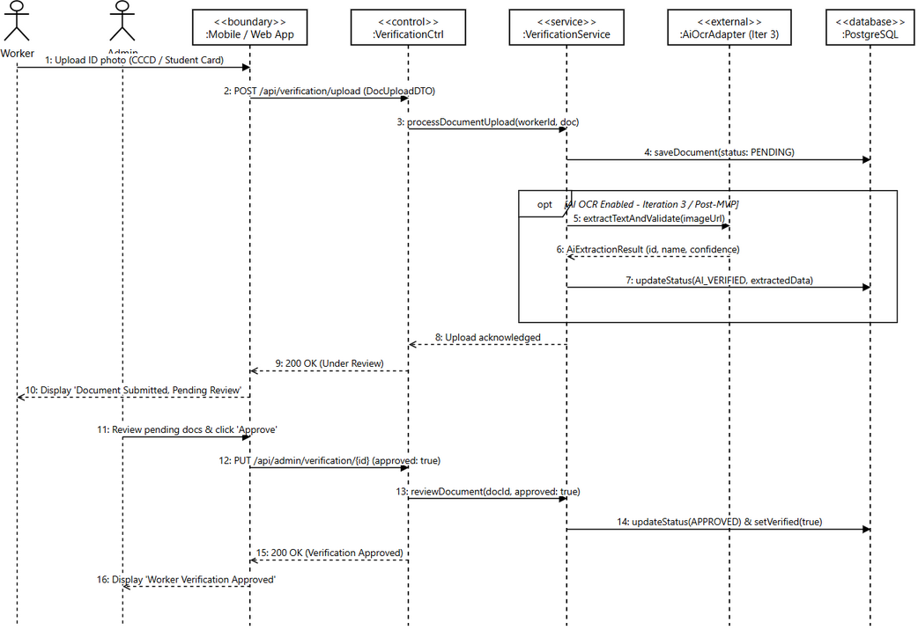
Figure 1.8: Sequence Diagram for Document Verification (AI & Manual)

1.2.6 Worker Skill Point, Tier & Platform-Proven Recalculation (SD-06)
This sequence shows the administrative or post-shift trigger to recalculate worker skill scores, update skill tiers (Bronze to Platinum), and grant the Platform-Proven badge based on verified performance metrics.
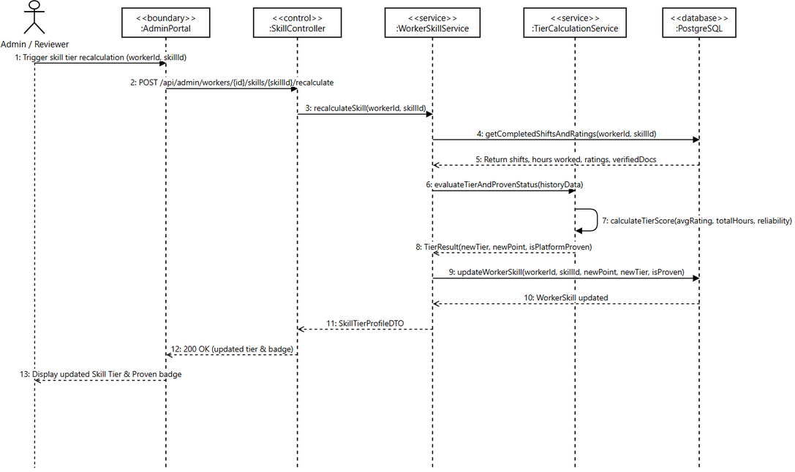
Figure 1.9: Sequence Diagram for Skill Point, Tier & Platform-Proven Update

1.2.7 Worker Matching, Fairness Ranking & Proposal Dispatch (SD-07)
This sequence illustrates candidate matching combining skill/distance scoring with the Fairness Engine (anti-starvation decay), allowing the organizer to review ranked recommendations and dispatch proposals.
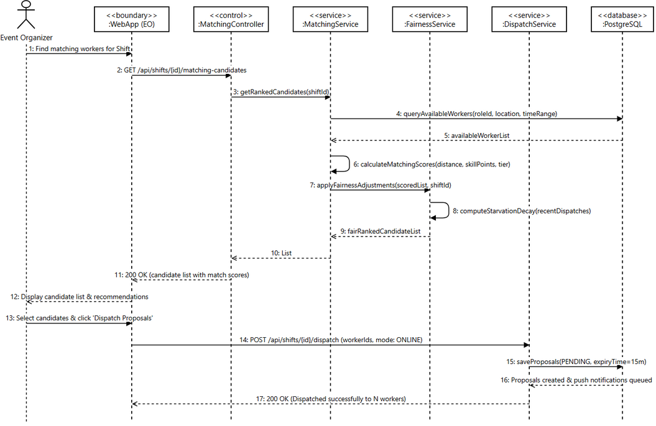
Figure 1.10: Sequence Diagram for Matching, Fairness & Proposal Dispatch

1.2.8 Worker Proposal Acceptance, Decline & Timeout Expiry (SD-08)
This sequence handles worker responses to shift proposals, confirming assignment and releasing conflicting invites when accepted, or handling expiration when the 15-minute response window lapses.
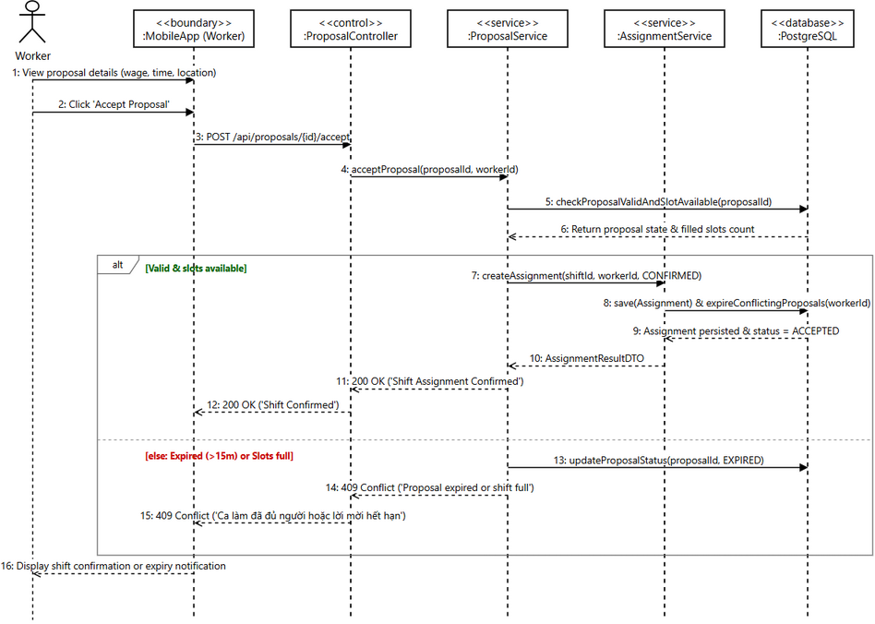
Figure 1.11: Sequence Diagram for Proposal Response & Expiry Processing

1.2.9 Emergency Worker Dispatch (SD-09)
This sequence covers urgent vacancy replacement under BR-88, bypassing manual organizer selection to immediately broadcast high-priority surge invitations to qualified nearby workers with emergency readiness.
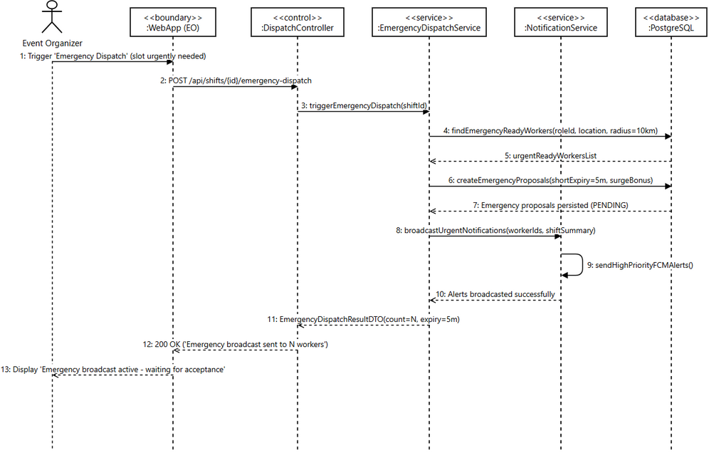
Figure 1.12: Sequence Diagram for Emergency Dispatch

1.2.10 Favorite Team Management & Direct Shift Invitation (SD-10)
This sequence details how organizers maintain their curated pool of preferred workers (My Team) and dispatch prioritized shift invitations before opening slots to general matching.
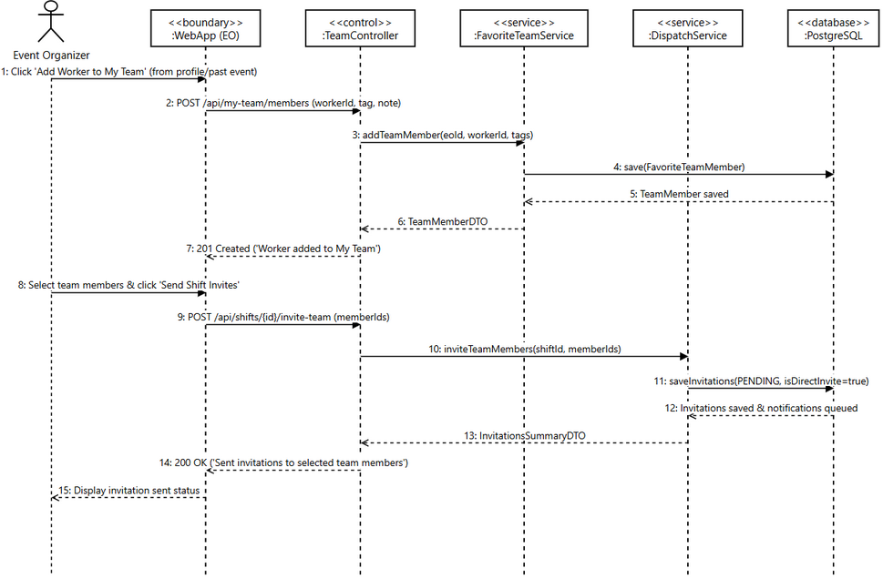
Figure 1.13: Sequence Diagram for My Team Management & Direct Invitations

1.2.11 Worker Group Creation & Member Management (SD-11)
This sequence depicts group leaders establishing worker groups, specifying specialized work domains, and managing active roster memberships.
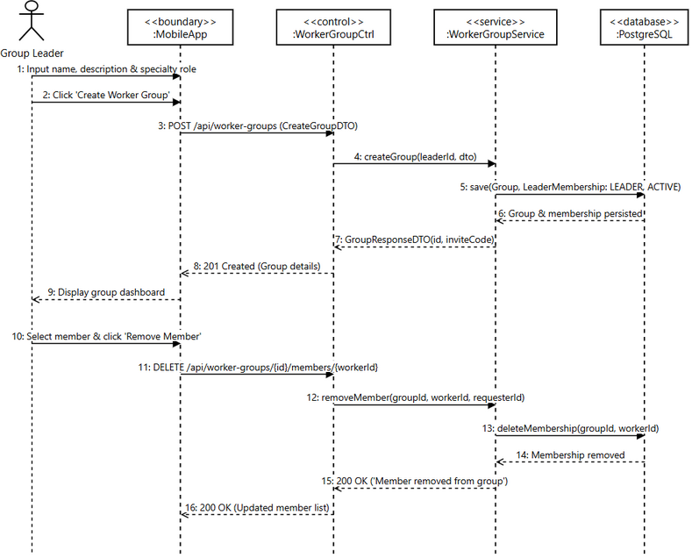
Figure 1.14: Sequence Diagram for Worker Group Creation & Member Roster

1.2.12 Group Invitation Link/QR & Join Request (SD-12)
This sequence outlines generating secure invitation tokens and QR codes for worker groups, allowing prospective workers to preview group credentials and submit join requests.
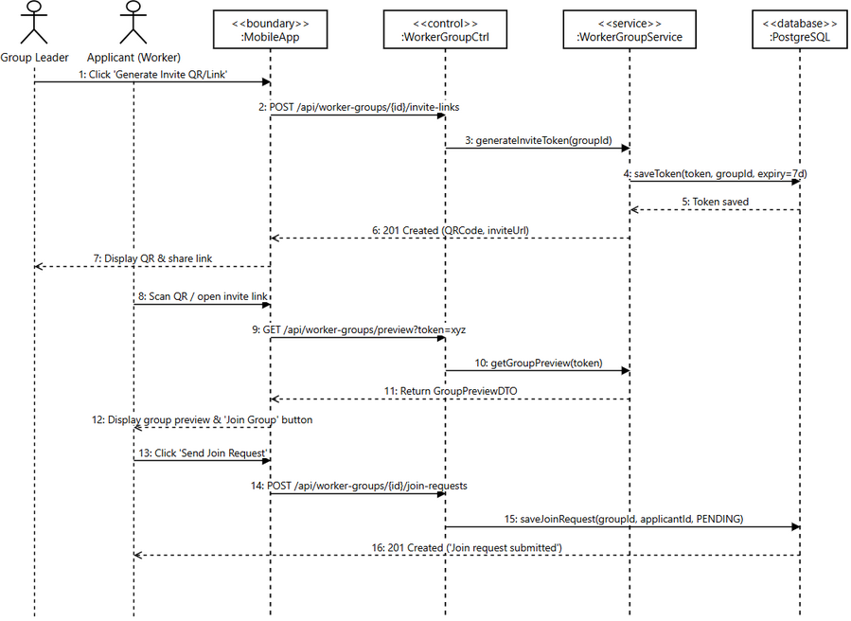
Figure 1.15: Sequence Diagram for Group Invitation QR/Link & Member Join Request

1.2.13 Pending Assignment Confirmation & Decline (SD-13)
This sequence specifies worker review of pending group or direct shift assignments, locking individual work schedules upon confirmation or reopening vacancy slots upon rejection.
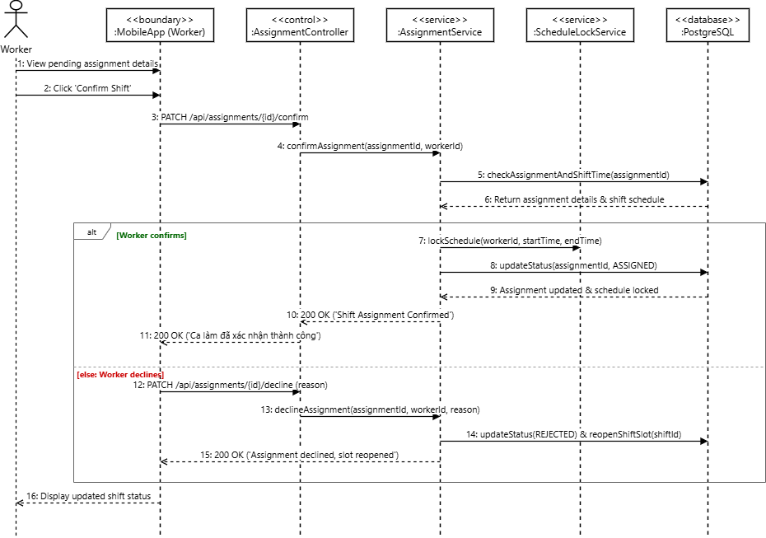
Figure 1.16: Sequence Diagram for Assignment Confirmation & Schedule Locking

2. Work Execution, Payment Confirmation & Reputation (FE-09 to FE-11)

2.1 Class Diagrams
Design set covering check-in/out attendance, work completion confirmation, external payment declaration, ratings, reliability score adjustment, and dispute resolution
2.1.1 Attendance, Checklist & Work Completion(CD-04)

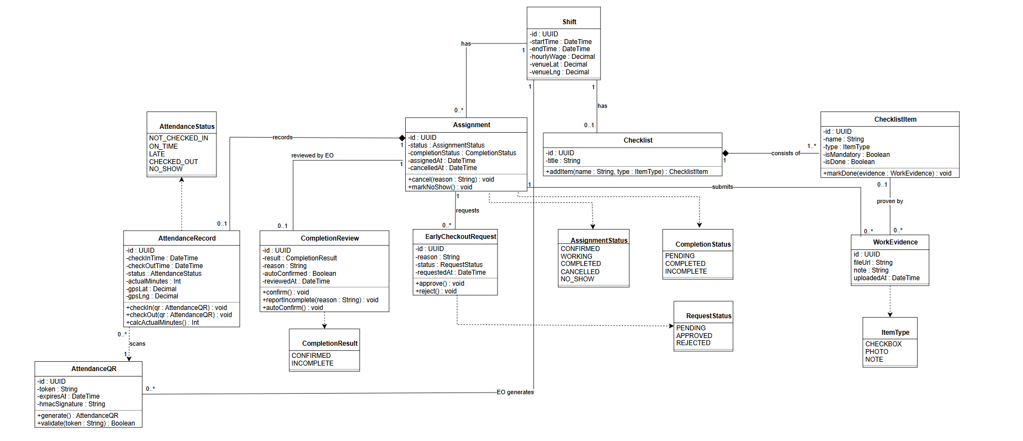

2.1.2 Payment Confirmation, Rating & Reliability(CD-05)
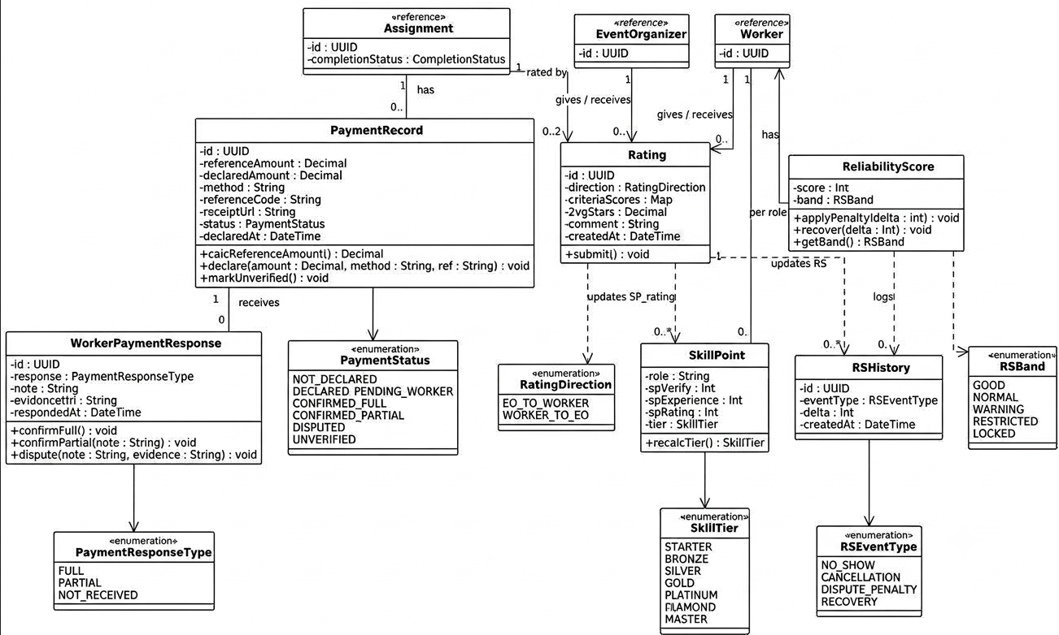
2.1.3 Dispute, Evidence & Appeal(CD-06)
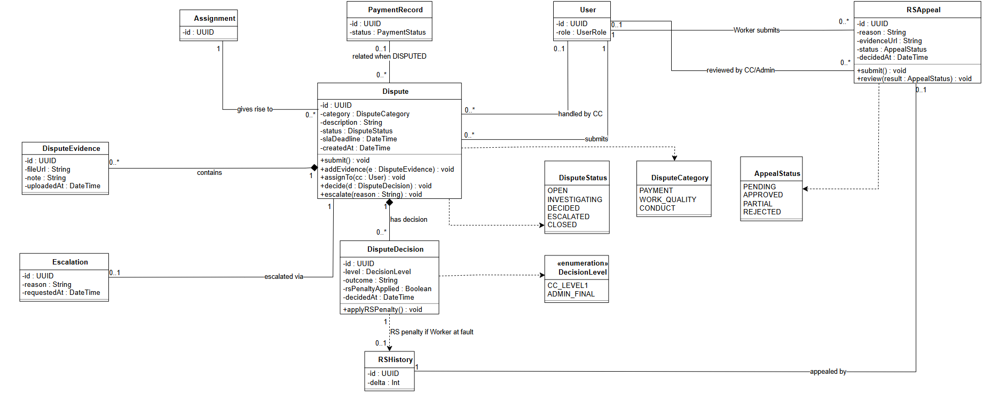

2.2 Sequence Diagram
2.2.1 EO Generates Attendance QR Code
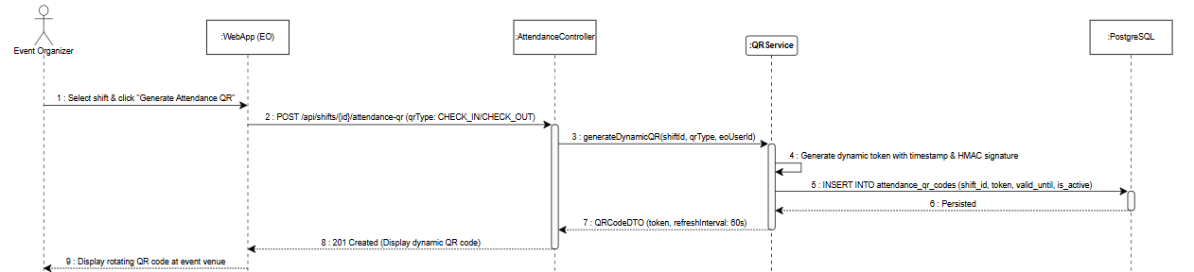
2.2.2 Worker Scans Check-in QR Code
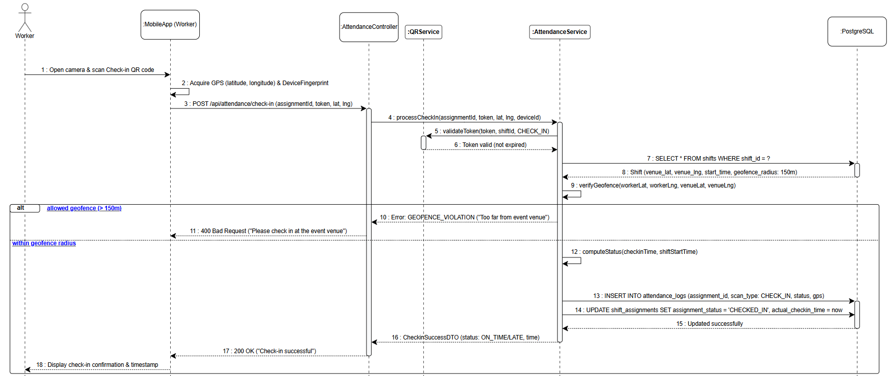
2.2.3 Worker Scans Check-out QR Code & Calculates Actual Hours
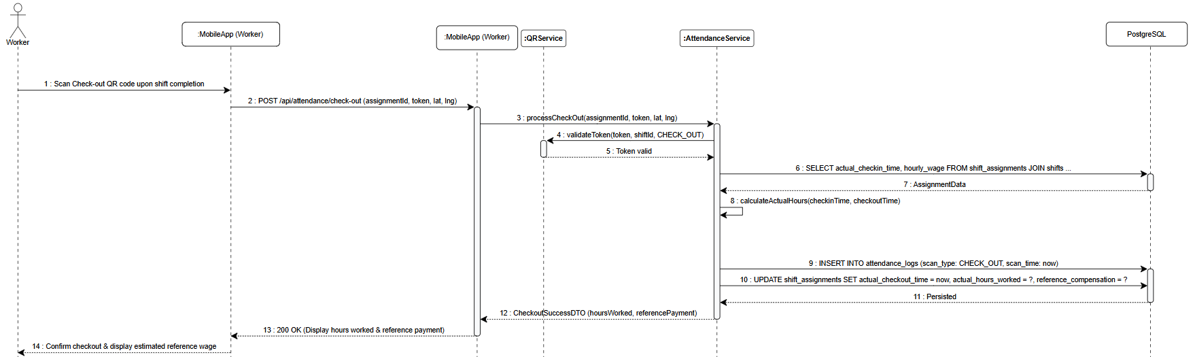
2.2.4 Worker Submits Early Checkout Request
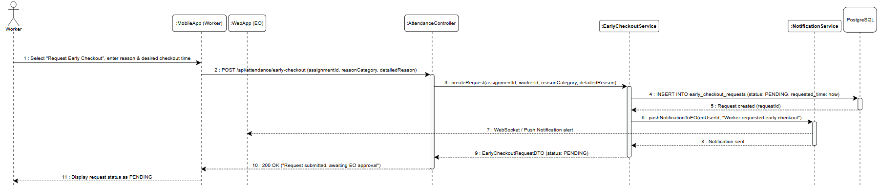

2.2.5 EO Reviews and Approves / Rejects Request
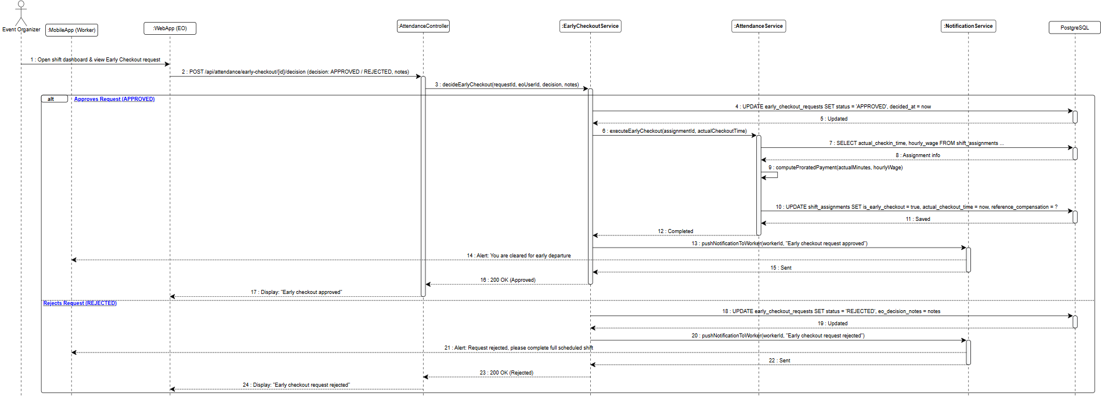
2.2.6 EO Creates Shift Job Checklist
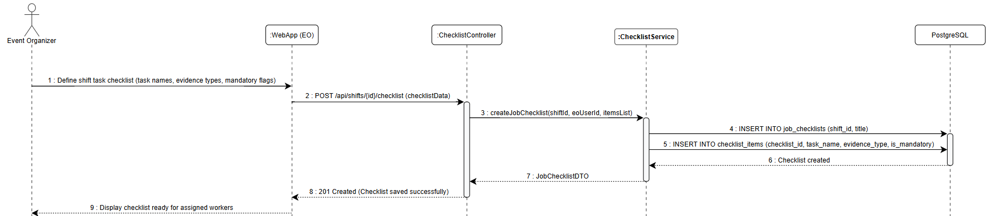
2.2.7 Worker Views Checklist & Updates Item Progress
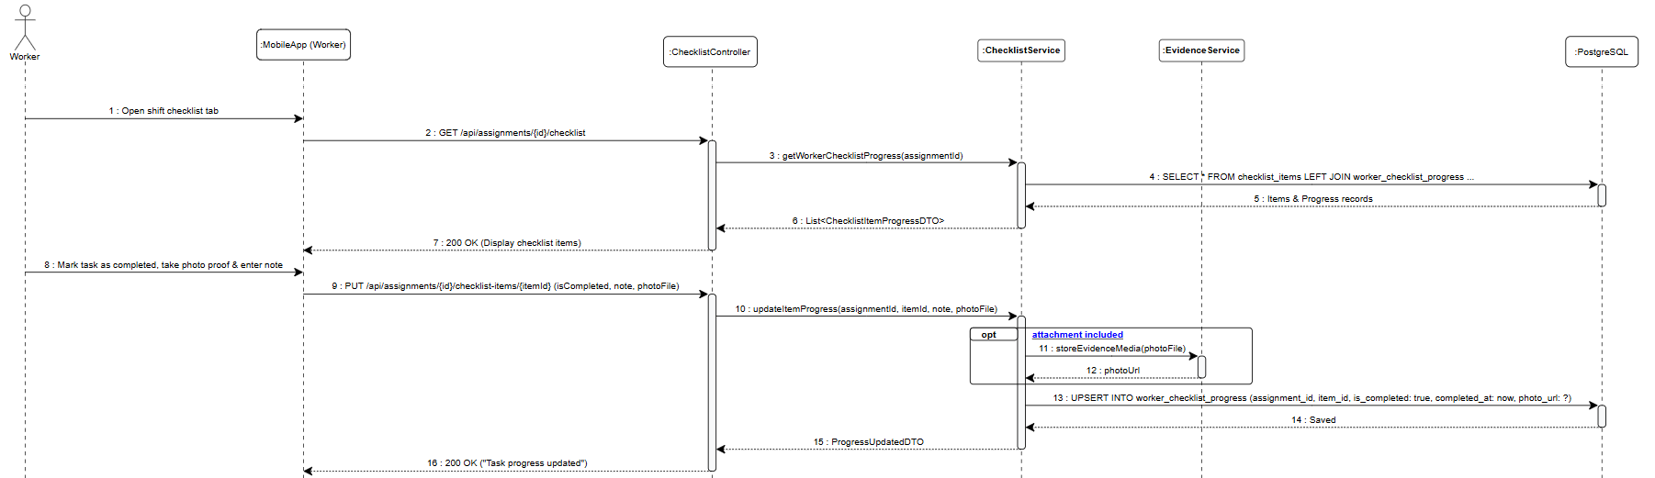
2.2.7 Worker Submits Overall Work Evidence
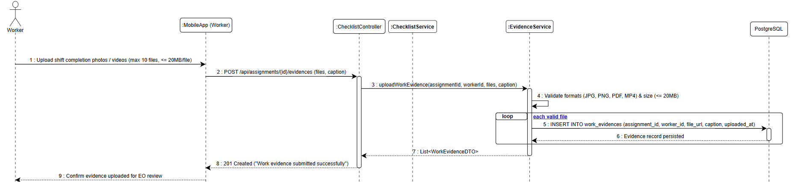
2.2.8 EO Confirms Work Completion (UC-82)
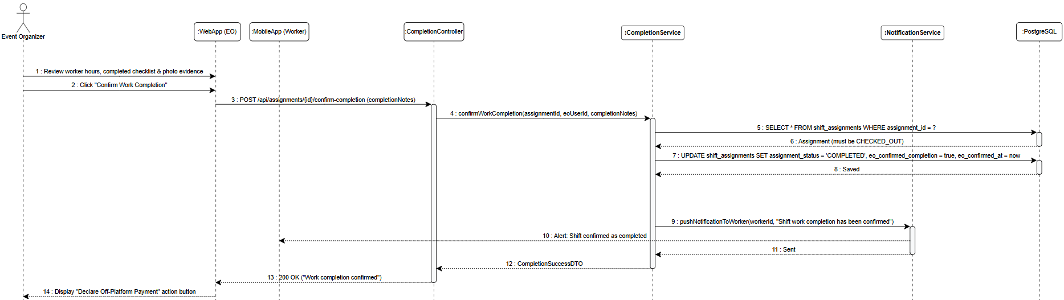
2.2.9 EO Reports Deficiency / Incomplete Work
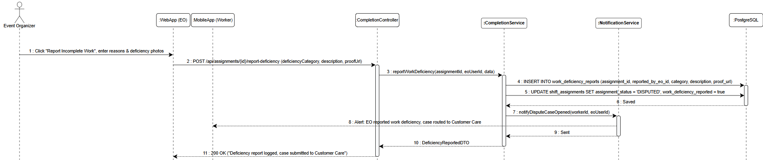
2.2.10 Automatic Handling on 72-Hour Timeout
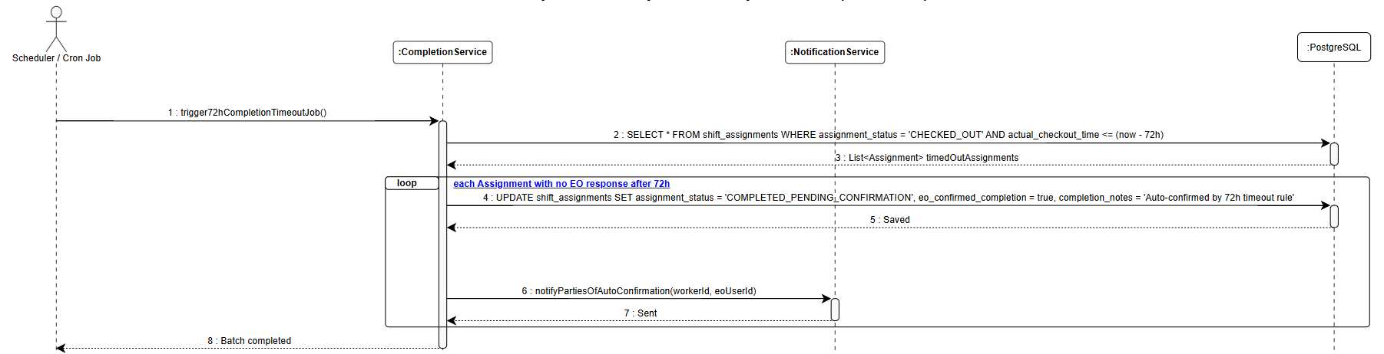
2.2.11 EO Settles Wage Off-Platform & Declares to CANi
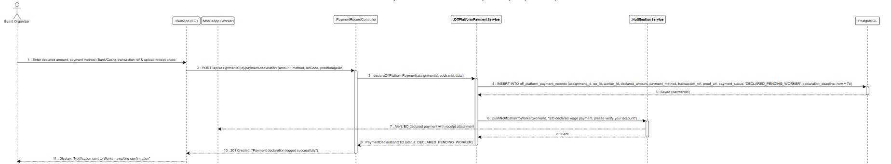
2.2.12 Worker Verifies Bank Account & Responds
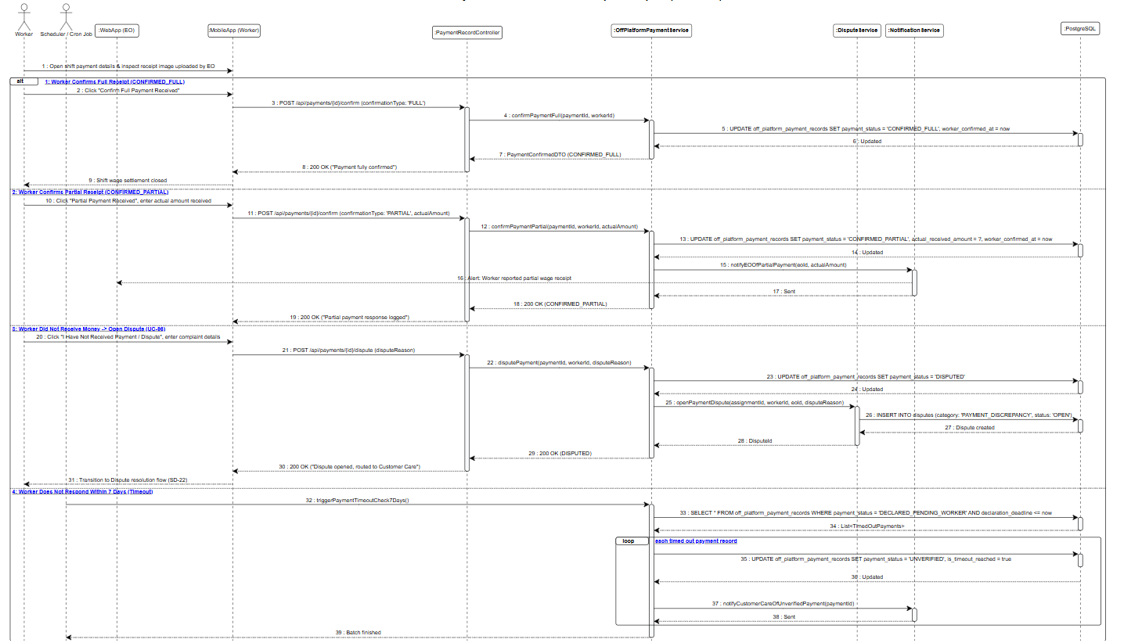
2.2.13 Detect No-show, Apply Penalty and Call Replacement
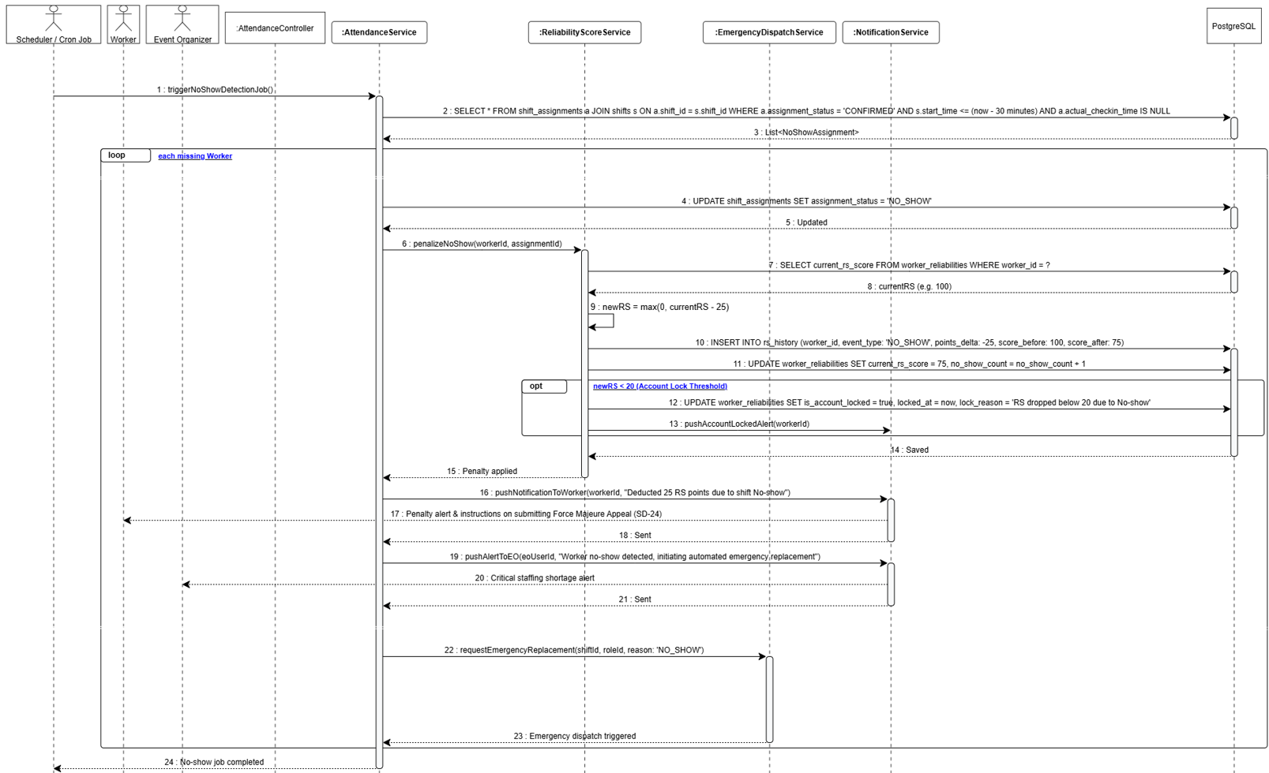
2.2.14 Worker Selects Cancel & Inspects Penalty Warning
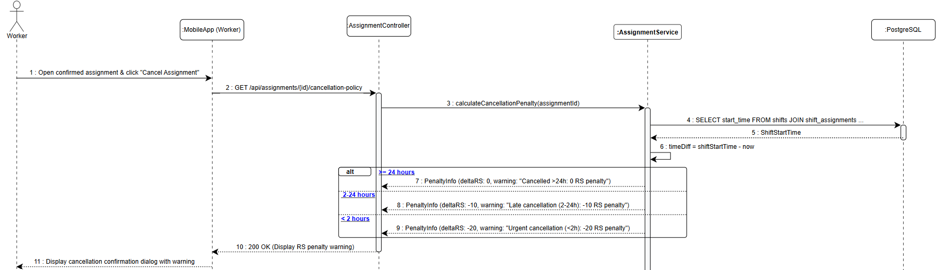
2.2.15 Worker Confirms Cancellation
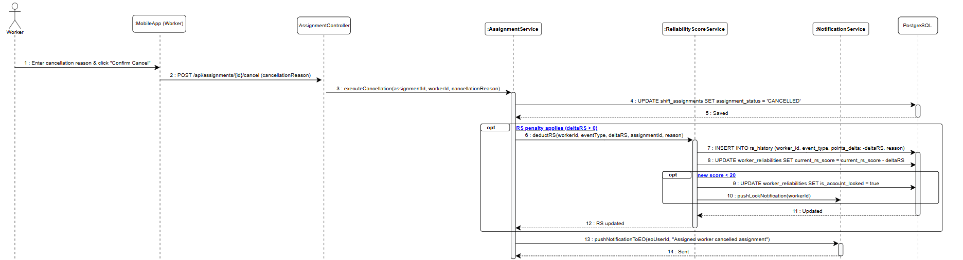
2.2.16 Trigger Emergency Dispatch
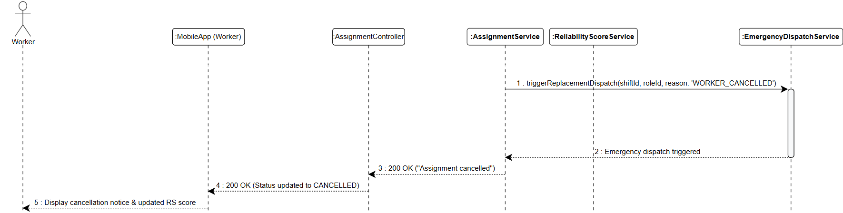
2.2.17 EO Rates Worker Across 5 Criteria
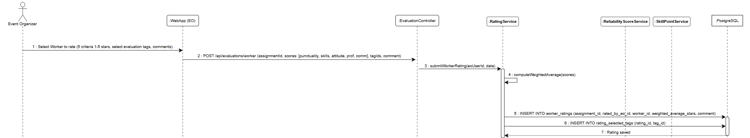
2.2.18 Update Reliability Score (RS) & Skill Points (SP)
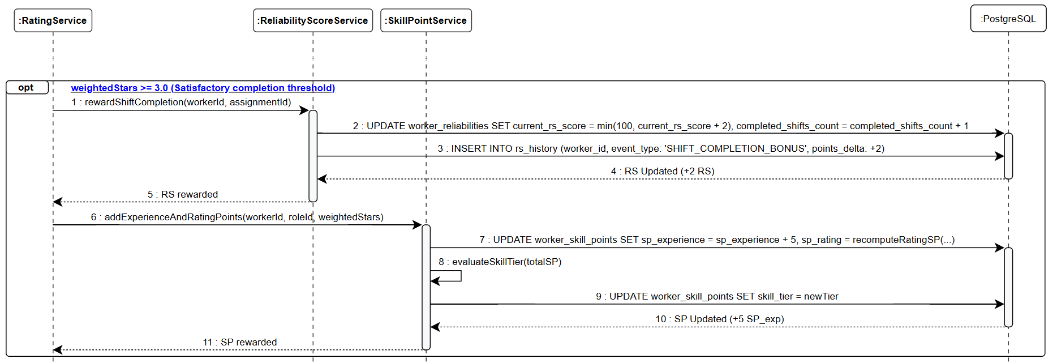
2.2.19 Check Account Lock Threshold
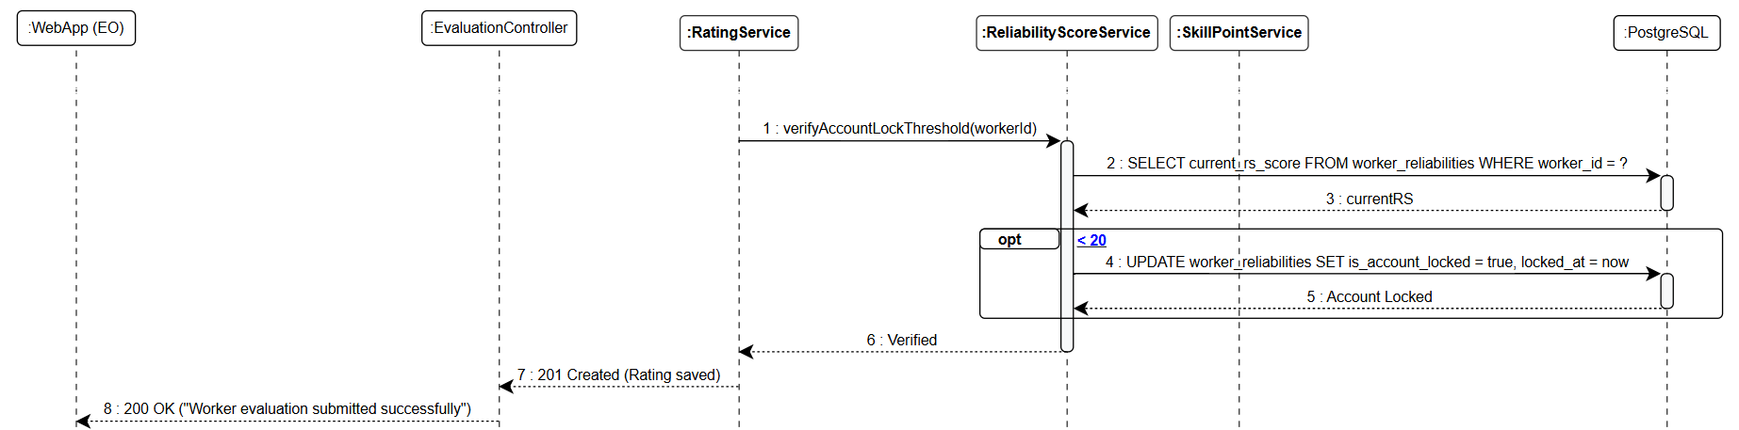
2.2.20 Worker Rates Event Organizer Across 5 Criteria
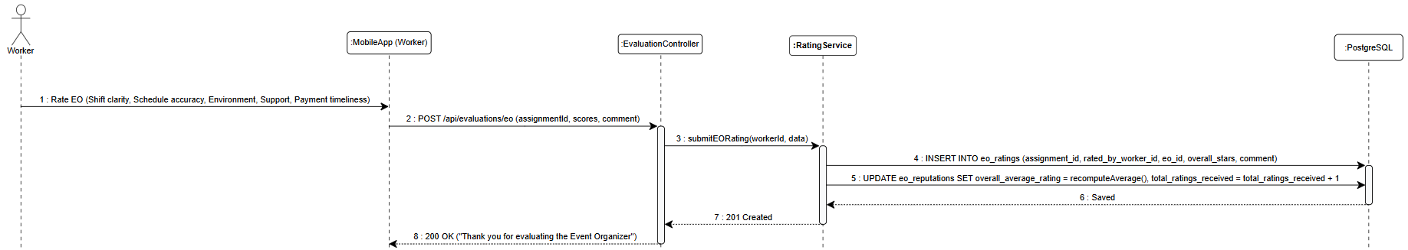
2.2.21 Complainant Submits Dispute
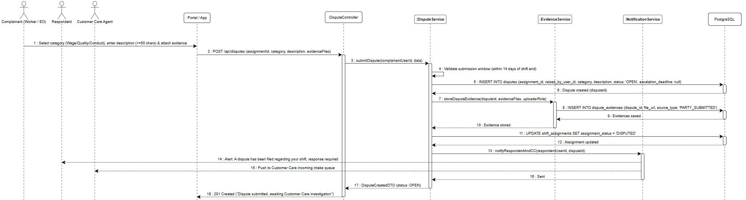
2.2.22 Customer Care Investigates & Requests Additional Evidence
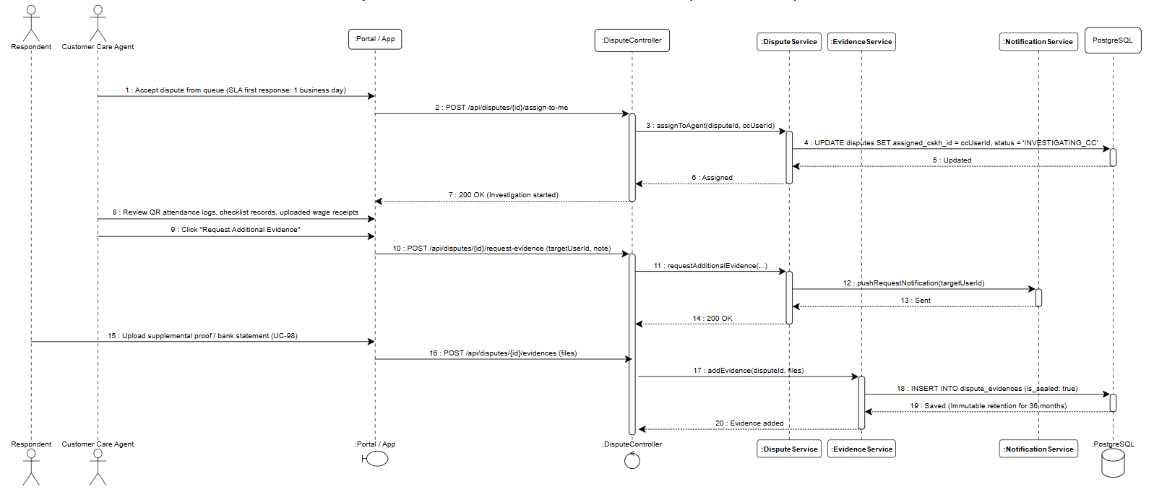
2.2.23 Customer Care Issues Level 1 Resolution Decision
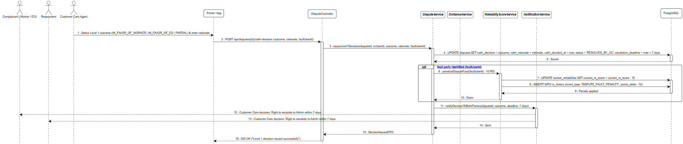
2.2.24 Appellant Escalates CC Decision to Admin Level
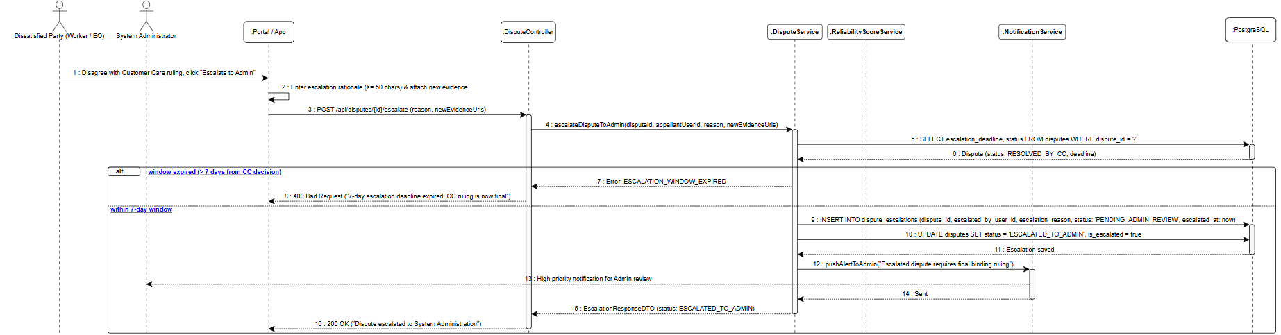
2.2.25 Administrator Reviews Case & Issues Final Binding Ruling
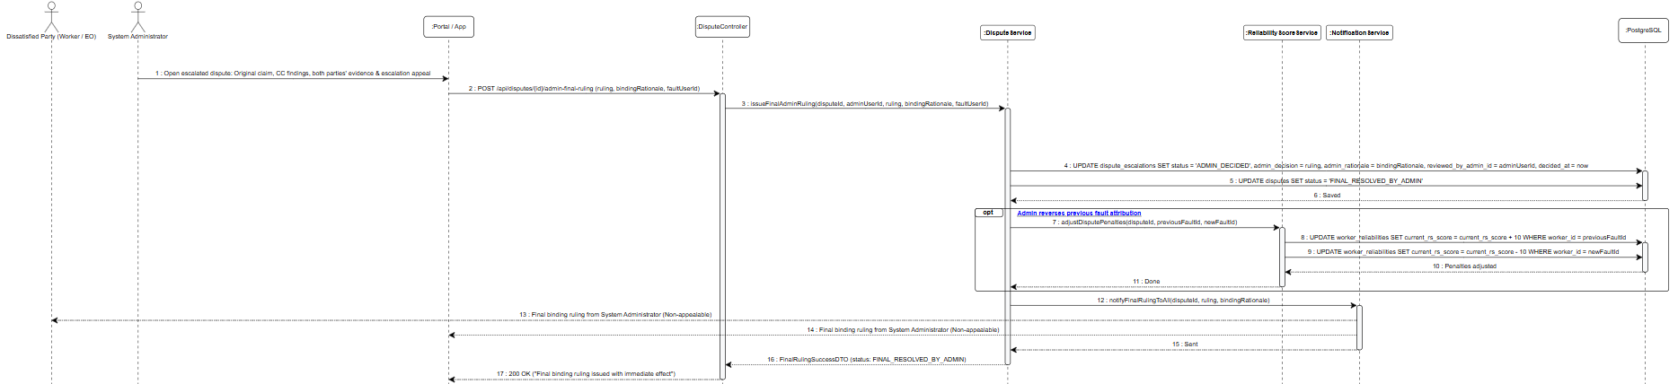
2.2.26 Worker Reviews Penalty & Submits Force Majeure Appeal
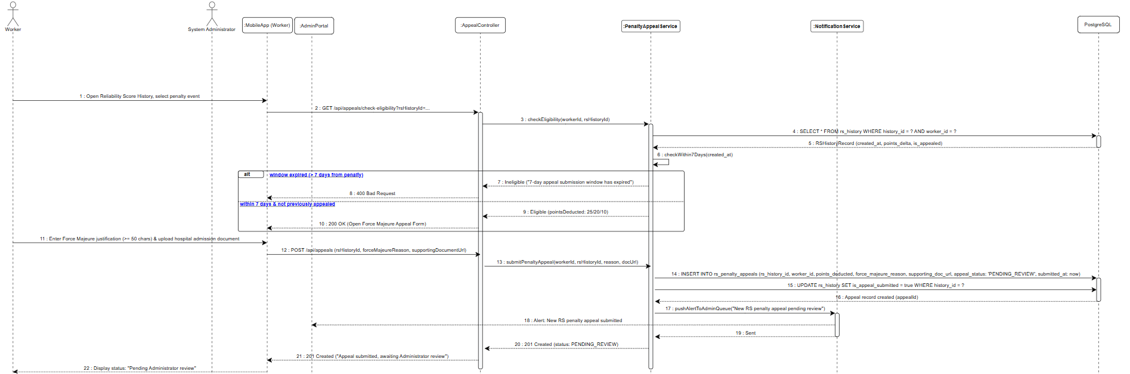
2.2.28 Administrator Reviews Documentation & Decides Point Restoration
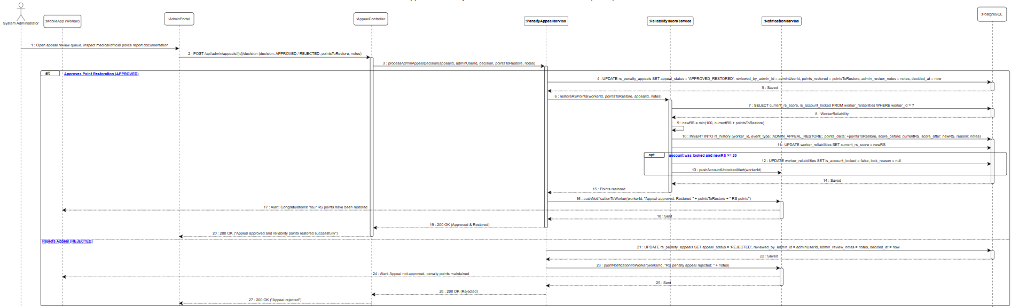

3. Account, Subscription & Platform Administration (FE-01, FE-12, FE-13, SUP)

3.1: Class Diagrams
The account, subscription, and platform administration domain is decomposed into three cohesive class diagrams adopting Clean Architecture (Controller – Service – Repository – Entity).
3.1.1 Account, Authentication & RBAC (CD-07)
Figure 3.1: UML Class Diagram for Account, Authentication & RBAC

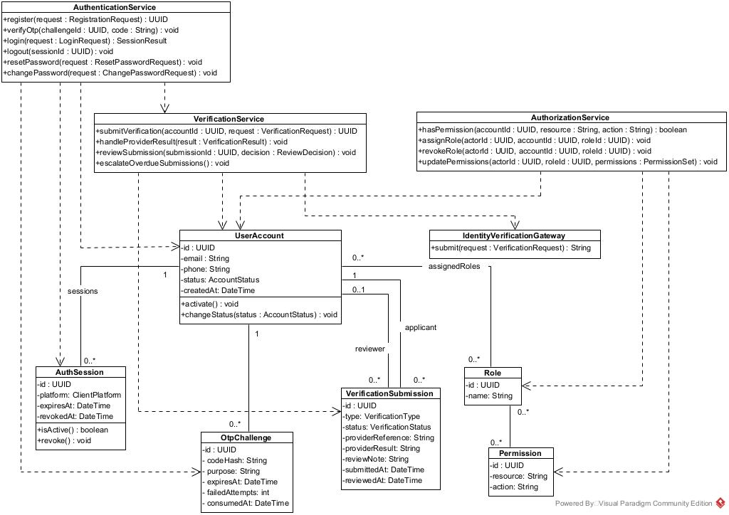
3.1.2 Subscription & Package Transaction (CD-08)
Figure 3.2: UML Class Diagram for Subscription & Package Transaction
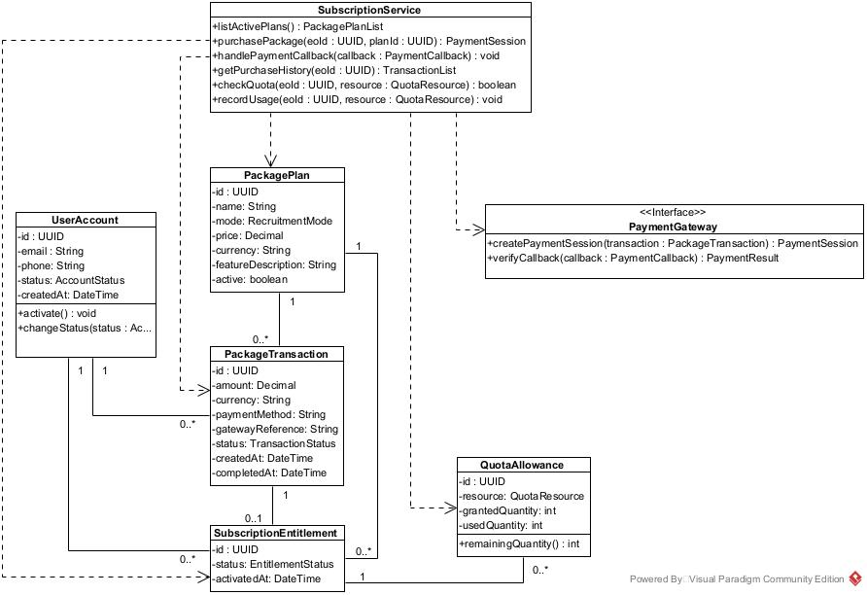
3.1.3 Account, Authentication & RBAC (CD-09)
Figure 3.3: UML Class Diagram for Account, Authentication & RBAC
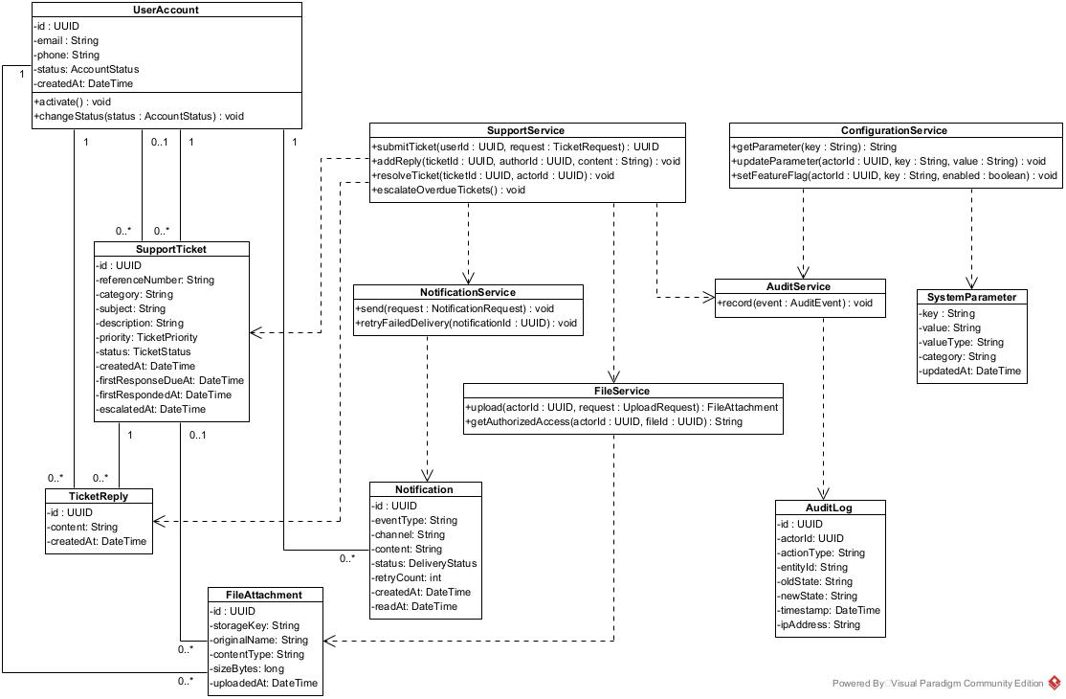

3.2 Sequence Diagrams
3.2.1: Register, Verify Email, and Approve EO Account (SD-25)
This sequence illustrates the EO registration process, including email verification, identity screening, and Customer Care approval before account activation.
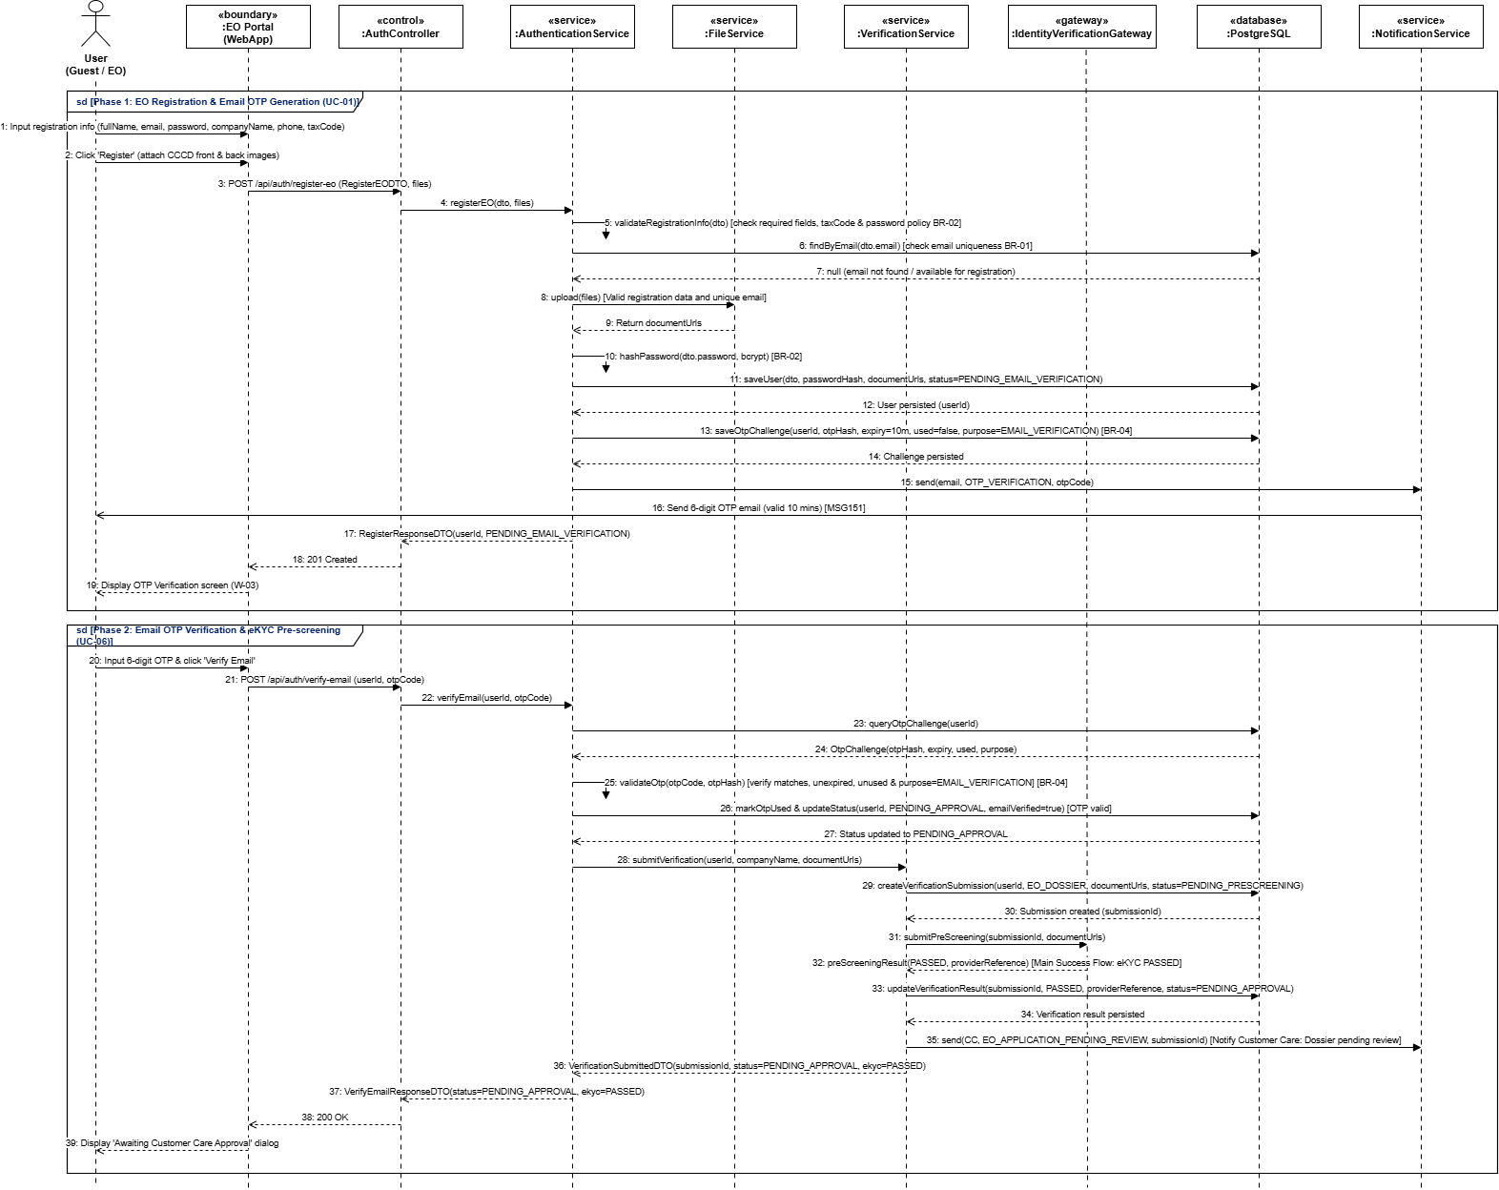
Figure 3.4:Sequence Diagram for Register, Verify Email

This sequence illustrates the EO registration process, including Customer Care approval before account activation. 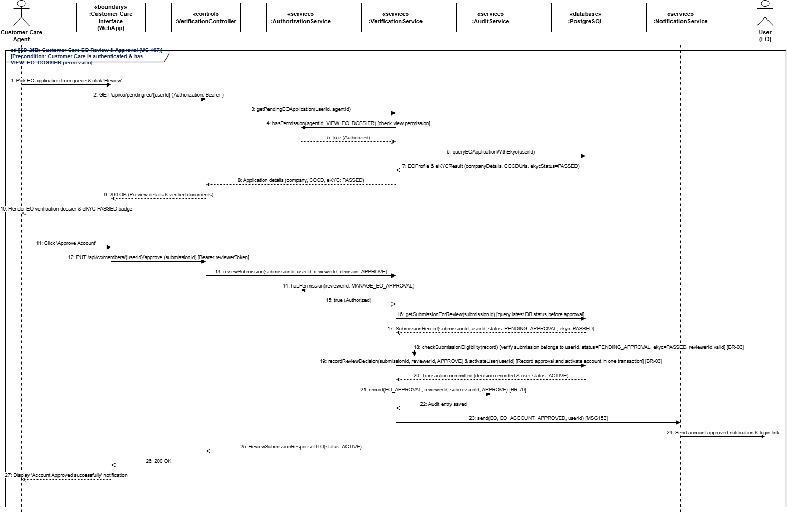

Figure 3.5:Sequence Diagram for Customer care approval EO registration

3.2.2: Login, Authorization Check, and Logout (SD-26)
This sequence illustrates user authentication, role/permission checking, session creation, and logout handling.
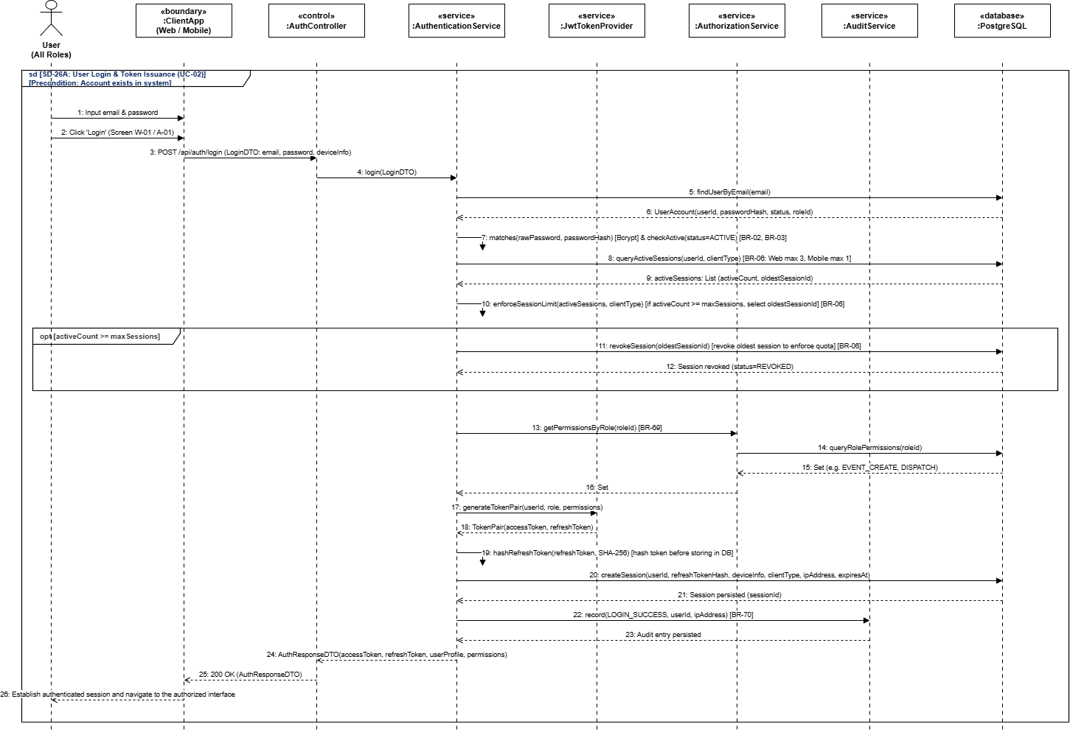

Figure 3.6:Sequence Diagram for Login, session creation
This sequence illustrates user authentication, role/permission checking, session creation, and logout handling.
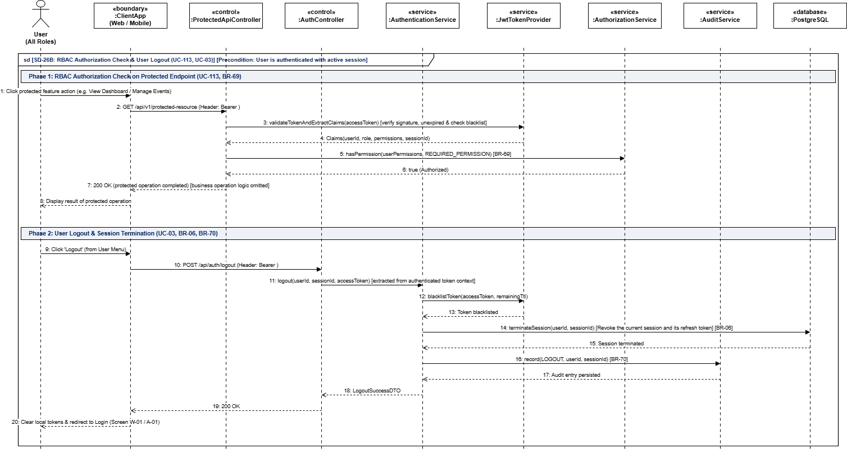
Figure 3.7:Sequence Diagram for Authorization Check, and Logout
3.2.3: Reset Password and Change Password (SD-27)
This sequence illustrates the password recovery and password change processes, including token validation, password validation, and session invalidation.
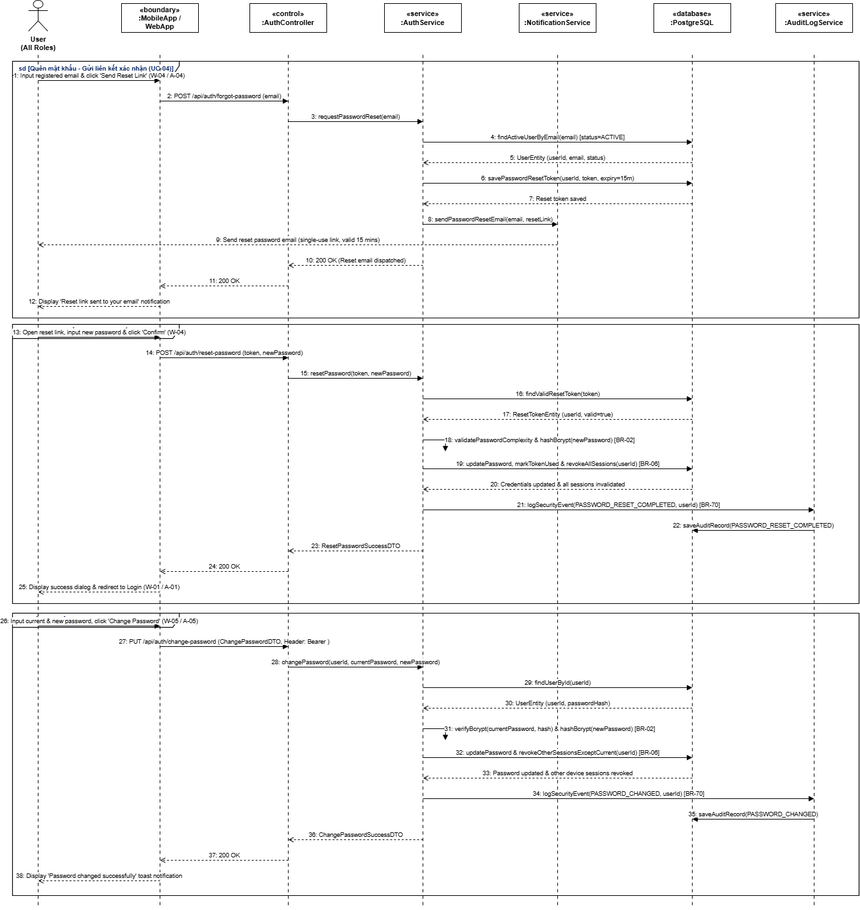
Figure 3.8:Sequence Diagram for Reset Password and Change Password

3.2.4: EO Purchases Service Package via VNPay Sandbox, Receives Callback, and Gets Quota (SD-28)
This sequence illustrates how an EO purchases a service package through VNPay, how the system processes the payment callback, and how usage quota is granted after successful payment.
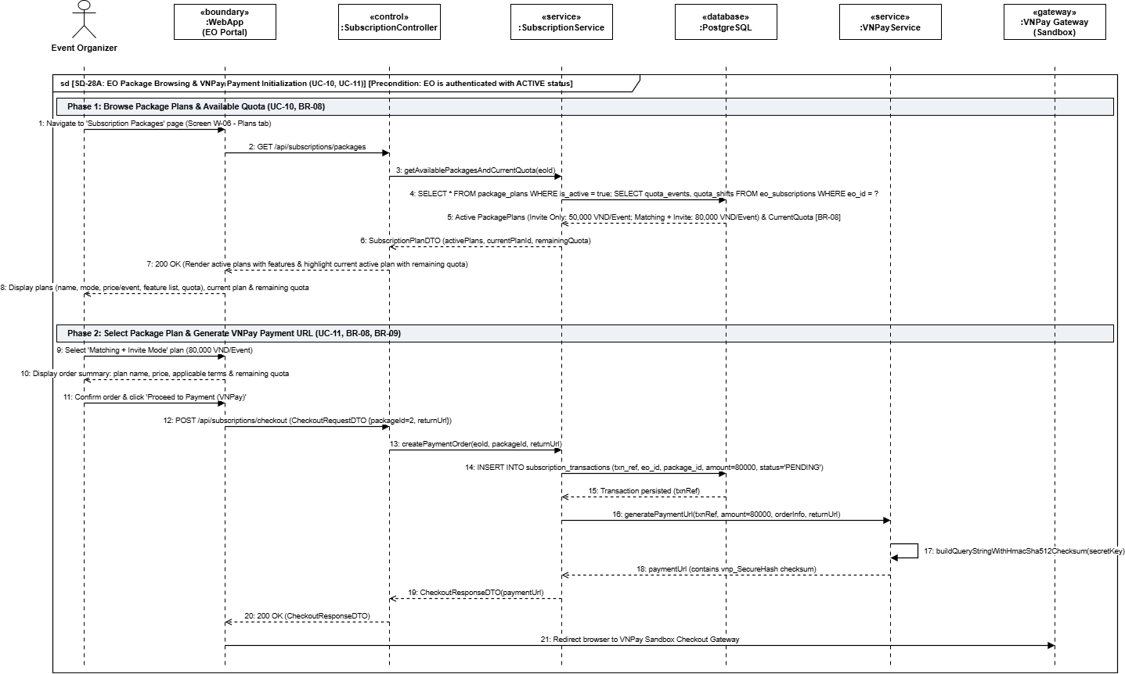
Figure 3.9:Sequence Diagram for EO select package plan and Purchases Service Package via VNPay Sandbox

This sequence illustrates how the system processes the payment callback, and how usage quota is granted after successful payment. 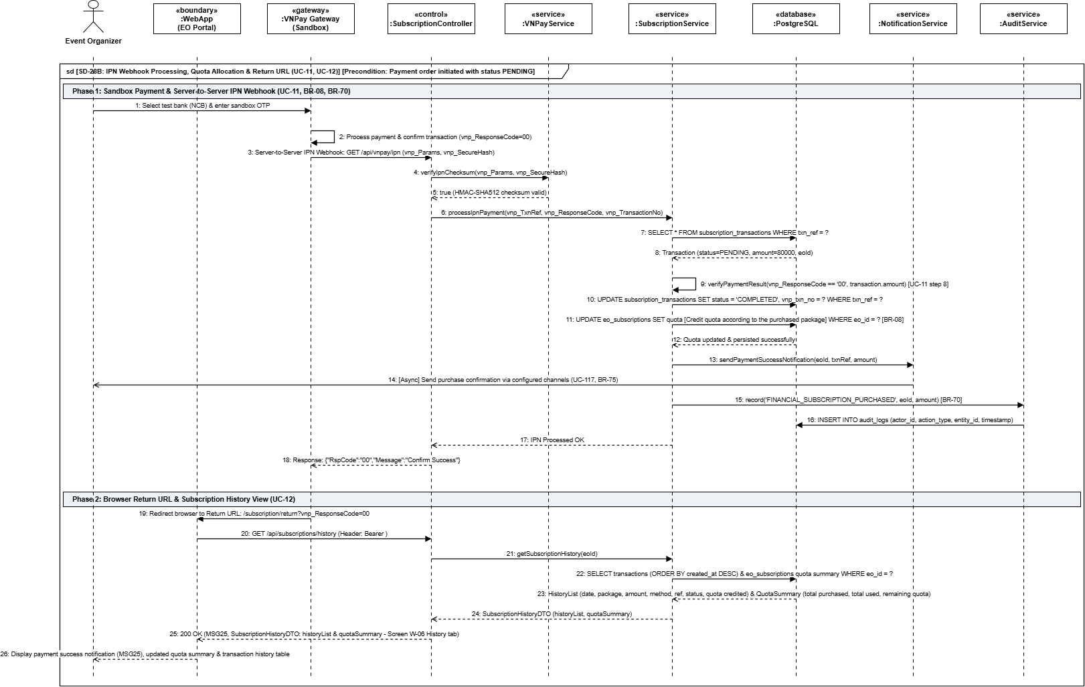
Figure 3.10:Sequence Diagram for Receives Callback, and Gets Quota

3.2.5: Submit Support Ticket and Handle Support Conversation (SD-29)
This sequence illustrates how users submit support tickets, receive responses from Customer Care, and continue the support conversation until resolution.
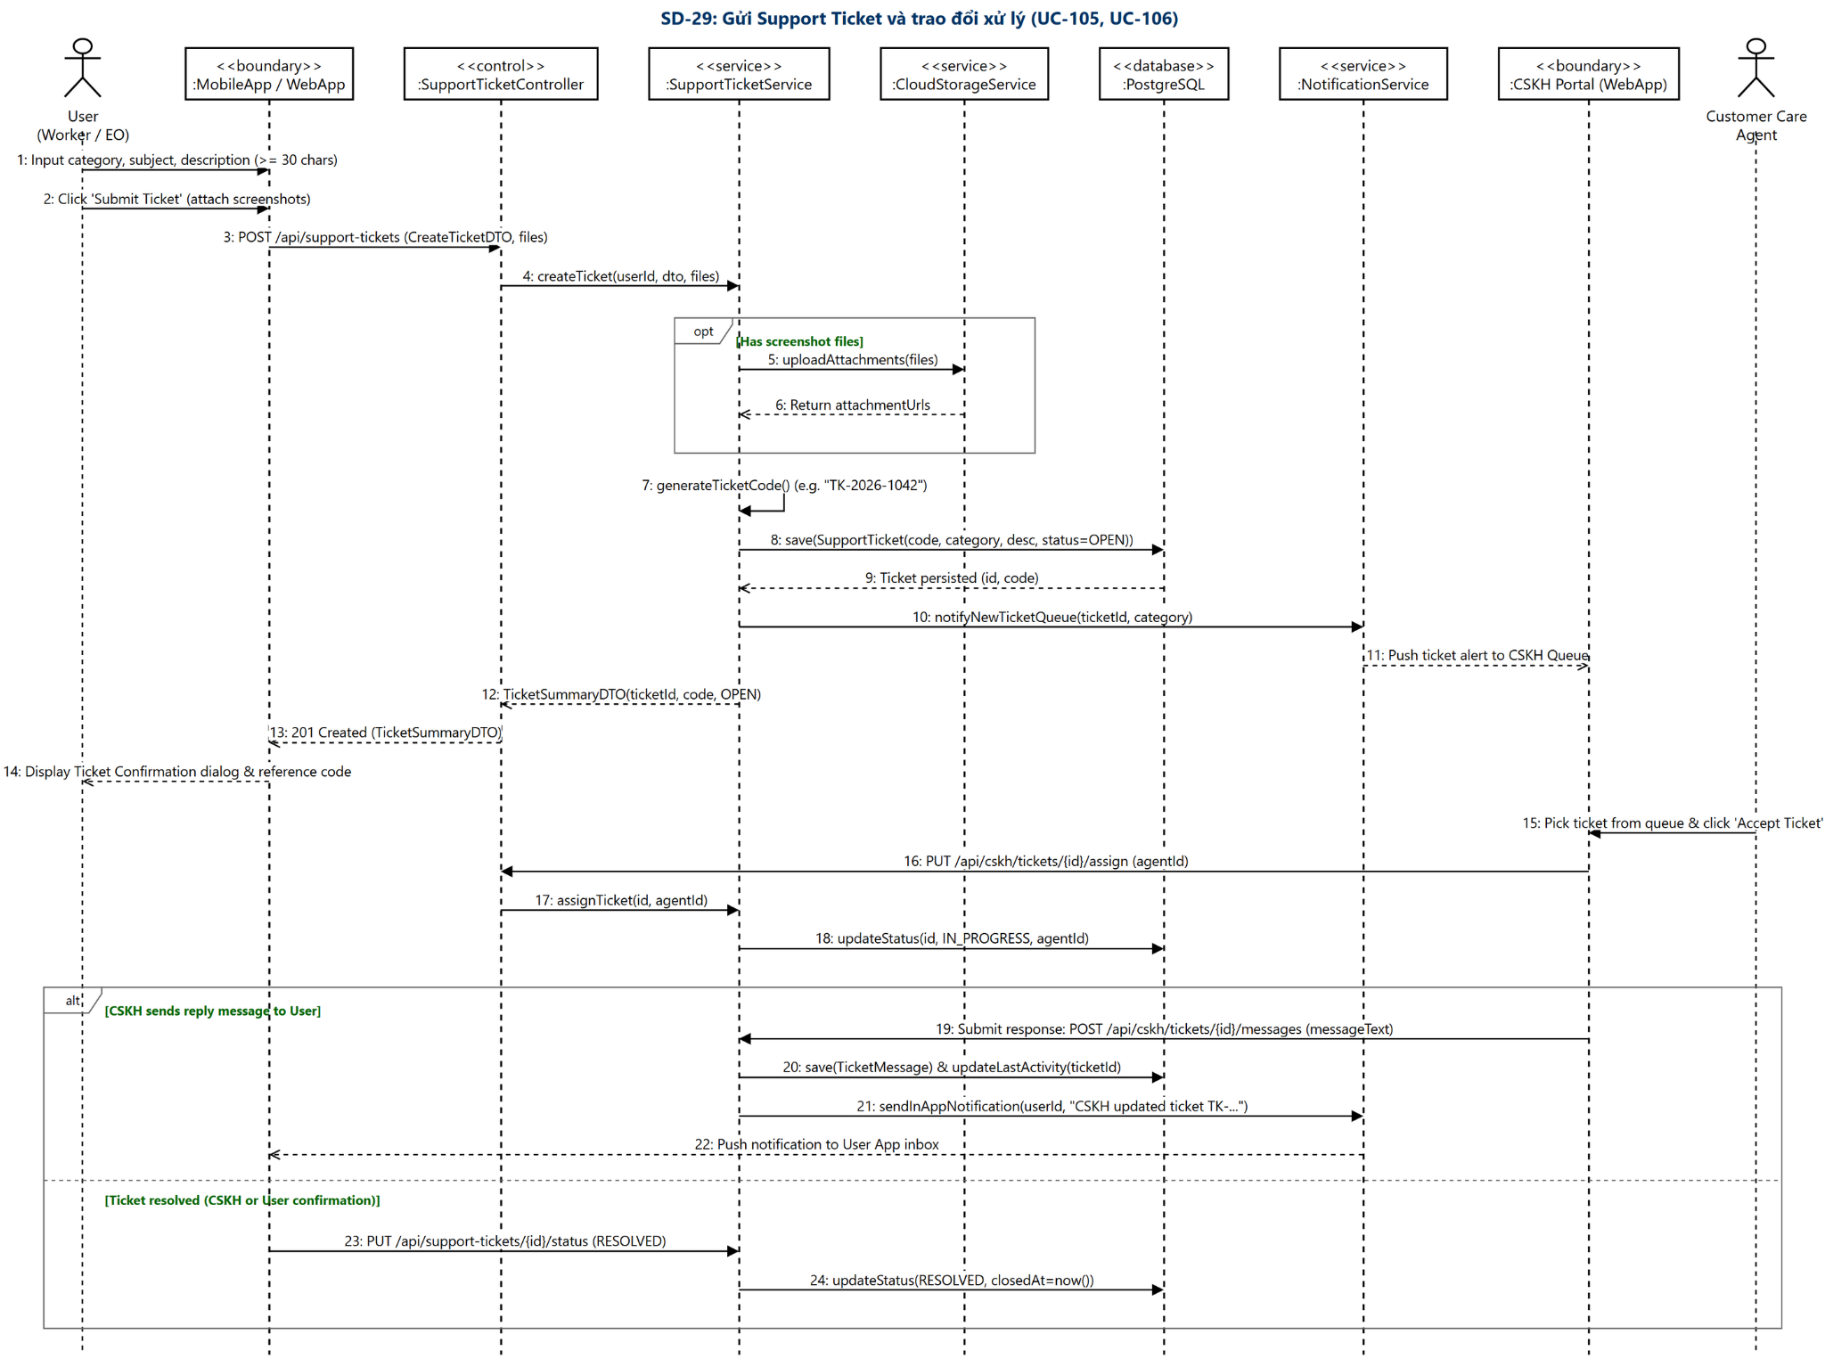
Figure 3.11:Sequence Diagram for Submit Support Ticket and Handle Support Conversation

3.2.6: Admin Updates Permissions, Parameters, and System Rules (SD-30)
This sequence illustrates administrative operations for updating RBAC permissions, system parameters, Skill Point rules, feature flags, and maintenance settings.
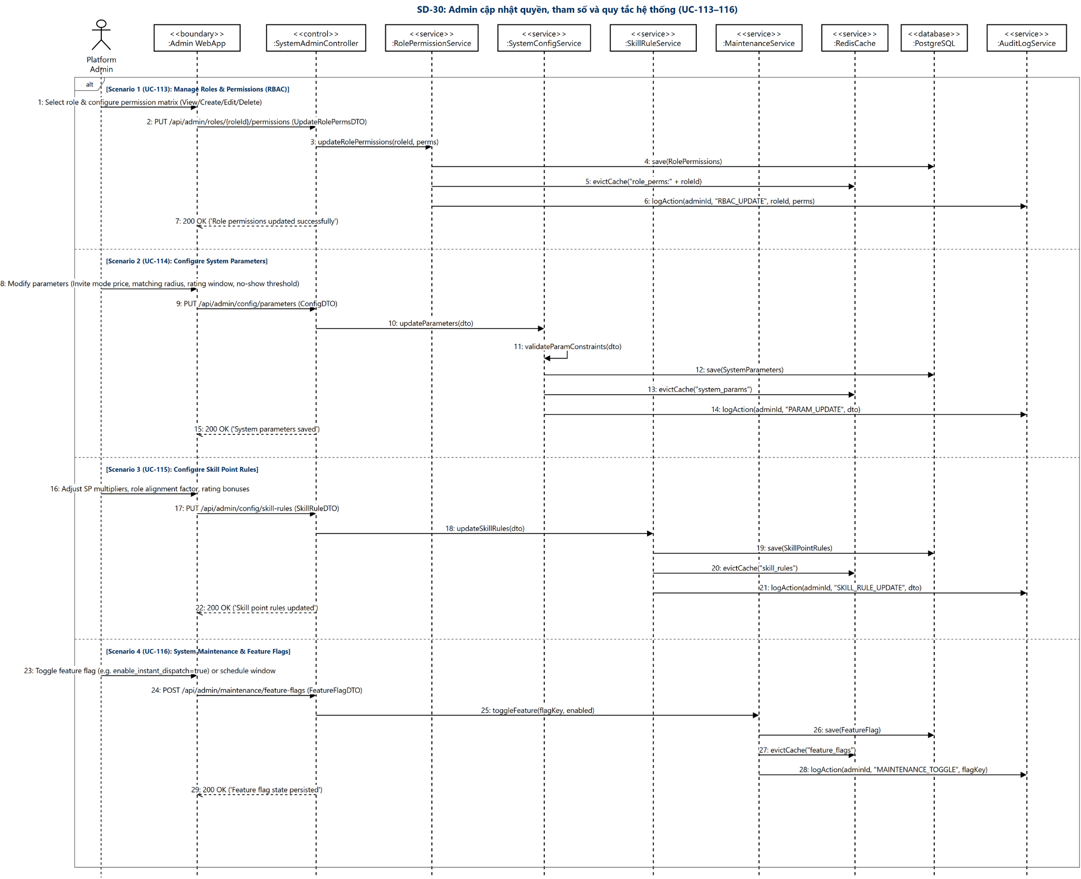
Figure 3.12:Sequence Diagram for Admin Updates Permissions, Parameters, and System Rules

3.2.7: Send In-App/Email Notifications and Handle Delivery Failures (SD-31)
This sequence illustrates notification delivery through In-App and Email channels, including user preference checks, delivery logging, retry handling, and failure processing.
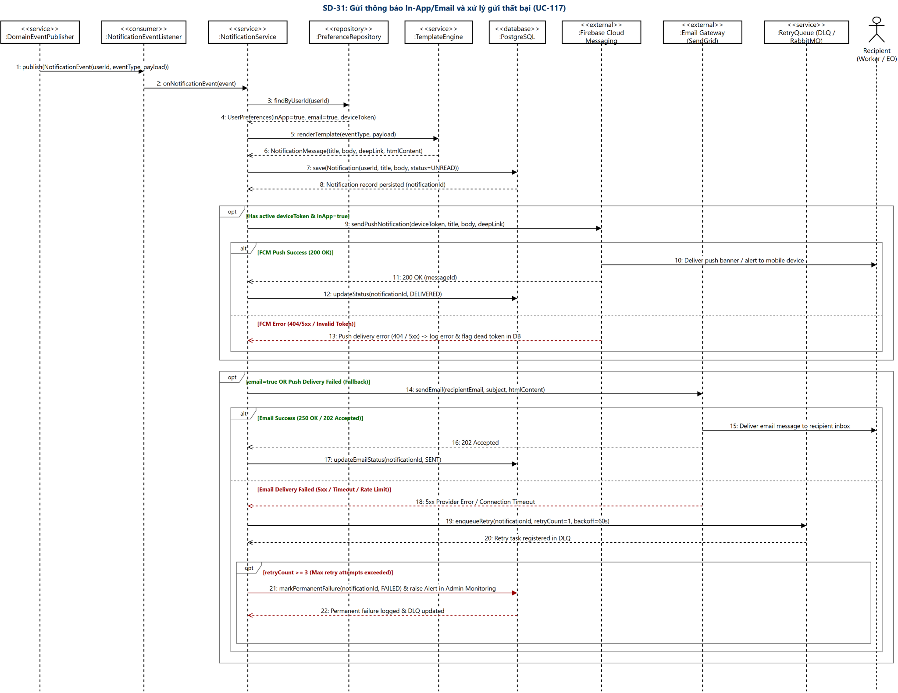
Figure 3.13:Sequence Diagram for Send In-App/Email Notifications and Handle Delivery Failures

III. Design for Non-Functional Requirements

1. Security Design
CANi implements a common security model across two client applications: a React Web application serving Event Organizer (EO), Admin, and Customer Care (CC), and a Worker mobile application. Both applications use the shared Spring Boot backend for authentication, authorization, and access to business data.
The Web application provides a common login entry point. After authentication, the system determines the account’s assigned role and displays the corresponding interface and permitted functions. Permissions are enforced by the backend regardless of the interface used.
The security design covers authentication and session management, role-based authorization, data protection, and the financial transaction recording, platform subscription payments, and data integrity. It follows the supporting use cases and security requirements specified in Report 3.

1.1 Authentication Flow
CANi uses JWT-based authentication with access tokens and rotating refresh tokens.
- The backend validates user credentials and account status. Failed attempts are recorded, and repeated failures trigger a temporary lock.
- After successful login, the system issues tokens and grants access based on the account’s role: EO, Admin, or CC on the shared Web, and Worker on the mobile application.
- Protected requests require valid tokens and appropriate permissions. Expired access tokens can be renewed using valid refresh tokens, which are rotated.
- Logout or a successful password change invalidates all active tokens under BR-03 and clears the client’s authentication state.
EOs must also obtain organizational approval before publishing Events or purchasing paid subscription plans, as required by BR-03.

a. Token Design
Aspect | Design Decision
Token format | Signed JSON Web Token using HMAC-SHA256, as specified in NFR-SEC-01.
Access token lifetime | 15 minutes. Expired or invalid access tokens are rejected when accessing protected resources.
Refresh token lifetime | Seven days, with refresh-token rotation as specified in NFR-SEC-01.
Authentication context | The authenticated identity and assigned permissions determine access to protected operations. Permissions are verified by the backend.
Password protection | Passwords are hashed using bcrypt with a work factor of at least 12, or Argon2id with unique salts, as permitted by NFR-SEC-01. Plaintext passwords are not stored or logged.
Password requirements | At least eight characters, including one uppercase letter, one digit, and one special character, following BR-02.
Failed login protection | Five consecutive failed login attempts result in a 15-minute account lock, following BR-02 and NFR-SEC-02.
Authentication rate limiting | Public authentication and OTP endpoints are limited to five requests per minute per IP address, following NFR-SEC-02.
Authentication context | The authenticated identity and assigned permissions determine access to protected operations. Permissions are verified by the backend.
OTP validity | OTPs remain valid for a maximum of ten minutes. A minimum 60-second interval is enforced between resend requests, following BR-04.
Session invalidation | Logout and successful password changes invalidate all active tokens across logged-in devices, following BR-03.
Account status | Locked, blocked, or deactivated accounts cannot obtain access contrary to their account restrictions.
Authentication logging | Successful authentication and security-related failures are recorded for monitoring and investigation.

b. CORS Configuration
CANi configures CORS to allow the shared React Web application to access the backend API when they are hosted on different origins. EO, Admin, and Customer Care (CC) use the same Web origin; access permissions are enforced separately through backend RBAC.
The following configuration is proposed for SDS V1. Deployment origins will be updated when the corresponding addresses are available.

Environment | Allowed Origins | Allowed Methods | Allow Credentials | Max Age
Development | Exact local CANi Web origin, including its configured port | GET, POST, PUT, PATCH, DELETE, OPTIONS | true | 3600 seconds
Staging | Exact HTTPS origin of the deployed CANi staging Web | GET, POST, PUT, PATCH, DELETE, OPTIONS | true | 3600 seconds
Production, if deployed | Exact HTTPS origin of the CANi production Web | GET, POST, PUT, PATCH, DELETE, OPTIONS | true | 3600 seconds

1.2 Authorization & RBAC Implementation
CANi enforces role-based access control on the backend. EO, Admin, and Customer Care (CC) share the CANi Web application, while Workers use the Worker application. After login, the system determines the account’s assigned role and displays the permitted functions.
Aspect | Decision
RBAC implementation | The Spring Boot backend verifies the authenticated account’s role and permissions before executing protected operations, following NFR-SEC-03, BR-69, and BR-71.
Supported roles | Event Organizer, Worker, Customer Care, and Admin.
Web access | EO, Admin, and Customer Care use a shared Web application. Navigation and available actions reflect the authenticated account’s permissions.
Admin permissions | Admin can access administrative functions and the functions available to Customer Care. Applicable business rules and operational approval controls remain enforced.
Customer Care scope | Customer Care staff manage user verification and dispute mediation. Customer Care cannot alter system configuration or execute administrative overrides.
EO access | EOs can manage their own organization information, Events, Shifts, staffing, completion reviews, My Team rosters (EOWorker), and wage payment declarations. Publishing Events and purchasing paid subscriptions require organizational approval under BR-03.
Worker access | Workers can manage their own profiles and availability, respond to proposals, access their Assignments, perform attendance activities, confirm received wage declarations, view earnings summaries, and use two-way rating, dispute, and appeal functions.
CC access | CC can review verification submissions, handle assigned disputes, inspect relevant evidence, and mediate payment disputes. CC cannot directly disburse funds or alter wage declarations, following BR-41 and BR-59.
Record-level authorization | The backend checks ownership or the authorized relationship to each requested record. Changing an Event, Assignment, dispute, or transaction identifier does not grant access to another user’s data.
Workflow restrictions | Permission checks also consider account status and the relevant business state. A valid role alone does not authorize an operation that violates verification, Assignment, dispute, or financial processing rules.
Subscription and dispute rules | Subscription package quota processing follows BR-08 enforcement. Dispute resolution settlements comply with formal verification and cannot be manually overridden contrary to BR-53 and BR-54.
Unauthorized access | Requests without valid authentication are rejected. Authenticated requests without the required permissions are denied without exposing protected data.
Audit logging | Privileged operations, including account status changes, subscription plan adjustments, configuration updates, and KYC verification reviews, are recorded with user ID, IP address, and timestamp, following BR-70.
My Team access | EOs can maintain and manage their private roster of verified workers (EOWorker), mark favorite workers, or blacklist non-compliant workers. Workers can only view the EO teams to which they have been enrolled.
Two-way performance review | Both EO and Worker can submit reviews within 7 days following shift completion. EO evaluates Worker across 5 criteria (20% each); Worker evaluates EO across 3 criteria (33.3% each). Unsubmitted reviews are automatically closed after 7 days with NO RATING (null status), preventing score inflation.

1.3 Data Protection
CANi protects sensitive data across the shared Web application, Worker application, and backend. Protection mechanisms follow the encryption, access control, financial integrity, and audit requirements defined in Report 3.
Data Category | At Rest | In Transit | Notes
Passwords | Salted hashes using bcrypt with a work factor of at least 12, or Argon2id, following NFR-SEC-01. | HTTPS/TLS 1.3. | Plaintext passwords are never stored or logged. Password hashes are not returned in API responses.
Personal identity information | One-way cryptographic salted hash for CCCD numbers; identity verification images stored in private object storage accessed via short-lived Pre-Signed URLs (15 mins), complying with Decree 13/2023/ND-CP and NFR-SEC-04. | HTTPS/TLS 1.3. | Access is restricted to the account owner and authorized CC staff. Verification photos are purged or restricted post-approval. Verified identity fields follow BR-05.
Bank account information | AES-256 encryption for bank account numbers used in wage transfer declarations, following NFR-SEC-04. | HTTPS/TLS 1.3. | Access is limited to the account owner and relevant shift counterparts for external transfer purposes, following BR-56.
Attendance and dispute evidence | Access-controlled storage for attendance records, checklist evidence, and dispute attachments. | HTTPS/TLS 1.3. | Only relevant participants and authorized staff may access records within their permitted scope.
Payment declarations (off-platform wage settlement records) | Append-only payment transaction log (PaymentLog) with cryptographic checksums, following NFR-SEC-05. | HTTPS/TLS 1.3. | EO wage declarations, payment proof attachments, worker confirmation statuses, and VNPay subscription transactions retain a traceable transaction history.
Platform subscription transactions | VNPay secure transaction records with HMAC-SHA512 signature verification. | HTTPS/TLS 1.3. | Separated from off-platform wage declarations. VNPay sandbox mode is used in staging/development and isolated from production.
Audit logs | Immutable records of privileged operations, following BR-70. | HTTPS/TLS 1.3 when accessed. | Logs include user ID, IP address, and timestamp. Access is restricted to authorized personnel.

2. Performance & Scalability Design
CANi uses a shared Spring Boot backend and PostgreSQL database to serve the React Web application and Worker application. The performance design focuses on reducing repeated database reads, optimizing frequently used queries, and preserving transaction consistency during concurrent operations.

2.1 Caching Strategy
What is Cached | Redis Key | TTL | Invalidation Trigger | NFR
vent search results for a filter and page | cache:event:list:{scope}:{filterHash}:{page} | 30 seconds | Event creation, activation, modification, cancellation, or archival affecting the results. | NFR-PER-01, NFR-PER-02
Event and Shift details for display | cache:event:detail:{eventId} | 60 seconds | Changes to Event or Shift information, lifecycle status, or staffing. | NFR-PER-02
EO staffing and Readiness summary | cache:event:staffing:{eventId} | 15 seconds | Assignment acceptance, cancellation, confirmed no-show, replacement, or Readiness recalculation. | NFR-PER-02
Wage and platform fee configuration | cache:pricing:config | 5 minutes | An authorized configuration update. | NFR-PER-02
Matching and Fairness rule configuration | cache:matching:config | 5 minutes | Changes to scoring weights, Fairness rules, or applicable feature configuration. | NFR-PER-03
vent search results for a filter and page | cache:event:list:{scope}:{filterHash}:{page} | 30 seconds | Event creation, activation, modification, cancellation, or archival affecting the results. | NFR-PER-01, NFR-PER-02
System configuration parameters | cache:system:config | 1 hour | SystemConfig update by Admin via administrative portal. | NFR-PER-02
Worker weekly availability slots | cache:worker:availability:{workerId} | 10 minutes | Worker updates availability preferences or accepts a shift. | NFR-PER-01, NFR-PER-03
EO My Team roster | cache:eo:myteam:{eoId} | 5 minutes | EO adds or removes worker from My Team, or status changes. | NFR-PER-01, NFR-PER-02
Worker reputation profile | cache:worker:reputation:{workerId} | 15 minutes | New review submitted, RS score updated, or shift completed. | NFR-PER-02, NFR-PER-03

Caching follows these controls:
● Access scope: Authorization is checked before returning cached data. User-specific results use a scope that distinguishes the relevant account and permissions.
● Invalidation: Relevant entries are invalidated after a successful database commit. TTL limits how long entries remain cached if no earlier invalidation occurs.
● Current-state validation: Proposal acceptance rechecks capacity, proposal validity, Worker eligibility, and schedule conflicts against authoritative records. Cached staffing counts cannot authorize an Assignment.
● Financial consistency: Platform subscription transactions via VNPay and off-platform wage payment declarations and confirmations use authoritative database transactions rather than cached states to prevent data inconsistency.
● Time-sensitive processing: Proposal expiry and QR validity are enforced independently of display-cache TTLs.
● Cache failure: Read operations fall back to the database if the cache is unavailable. Cache failure does not bypass authorization or business validation.

2.2 Database Query Optimization
Database optimization focuses on the access patterns of Event management, Matching, Assignments, attendance, and financial operations. The following measures are proposed for the PostgreSQL database.

Area | Design Approach | Related Functions / NFR
Query indexing | Create indexes for frequently filtered and joined fields, including ownership identifiers, Event and Shift relationships, Worker identifiers, statuses, and time ranges. Final index definitions follow the database schema and query plans. | FE-01–FE-07; NFR-PER-02
Composite indexes | Evaluate composite indexes for common query patterns, such as an EO’s Events by status, a Worker’s Assignments by status and time, and pending proposals by expiration time. | FE-01, FE-03, FE-04; NFR-PER-02
Pagination | Retrieve Event lists, Assignments, transaction histories, disputes, and audit records in bounded pages. Apply filtering and sorting on the backend. | NFR-PER-01, NFR-PER-02
Required-field selection | Select only the fields required by the requested screen or operation. Retrieve detailed records and evidence when needed. | NFR-PER-02
Related-record retrieval | Use suitable joins or batch retrieval to avoid issuing a separate query for every item in a roster, Assignment list, or proposal batch. | FE-03, FE-04; NFR-PER-02, NFR-PER-03
Matching candidate selection | Apply the approved eligibility filters before calculating suitability scores. Retrieve the required candidate data in batches to reduce repeated database access. | FE-03, FE-12; NFR-PER-03
Concurrent acceptance | Use transactional checks and appropriate locking for Shift capacity and Worker schedule conflicts. Revalidate eligibility before creating the confirmed Assignment. | FE-03; NFR-PER-06
Attendance writes | Keep QR validation and attendance updates focused on the relevant Assignment. Prevent duplicate attendance records through database constraints and transactional checks. | FE-05; NFR-PER-04, NFR-PER-07
Financial transactions | Commit payment declaration and worker confirmation status changes atomically. Validate VNPay IPN callbacks with database row-level locking to prevent duplicate subscription activations. | FE-07, FE-16; NFR-PER-07
Dashboard and reporting queries | Use filtered aggregate queries for staffing, financial, and operational summaries instead of loading complete histories into application memory. | FE-12, FE-15, FE-16; NFR-PER-02
Background processing | Process proposal expiration, Readiness recalculation, and other scheduled work in bounded batches. Keep external notification calls outside database transactions. | FE-03, SUP; NFR-PER-03, NFR-PER-08
Connection management | Use a bounded database connection pool aligned with the available backend and database resources. | NFR-PER-06, NFR-PER-07
Geospatial proximity indexing (PostGIS) | Create GiST spatial indexes on worker base coordinates (base_lat, base_lng) and shift venue location (location_lat, location_lng) for sub-second ST_DWithin 15km candidate filtering. | FE-03, FE-12; NFR-PER-03
Worker groups and team memberships | Composite index on (group_id, worker_id, status) for low-latency group roster retrieval and bulk invitation resolution. | FE-04, FE-10; NFR-PER-02
EOWorker and team relationships | Composite index on (eo_id, worker_id, is_favorited) for rapid My Team member retrieval and priority shift assignment. | FE-01, FE-03; NFR-PER-02
Review and reputation aggregates | Composite index on (reviewee_id, created_at) to accelerate profile reputation score calculation and recent feedback retrieval. | FE-06, FE-13; NFR-PER-02
Capacity tuning focuses on application resources, database connections, query efficiency, and cache behavior. Performance testing will cover concurrent proposal acceptance, Event and roster retrieval, attendance bursts, and subscription transaction flows. Notification measurements will distinguish backend processing time from external delivery time. Resource limits and measured bottlenecks will guide subsequent design revisions.

IV. Other Design Specifications
This section provides detailed technical specifications for the core business algorithms, external integration gateways, asynchronous background processing, and master data seeding governing the CANi On-Demand Event Workforce Coordination Platform, synchronized with the definitive project master specifications.

1. Core Algorithm Specifications

1.1 Workforce Matching & Multi-Criteria Soft-Ranking Algorithm (FE-03, FE-12)
The CANi Matching Engine coordinates on-demand event staffing through a high-performance 4-stage pipeline combining eligibility filtering, multi-criteria weighted sum scoring, fairness guardrails, and dispatch ratio sizing. Matching produces a ranked list of qualified candidates to assist Event Organizers (EO) in candidate selection without automated unverified over-dispatch.

a. Stage 1: Eligibility Filtering (Mandatory Hard Filter)
Candidates failing any of the following baseline criteria are immediately pruned prior to ranking:
• Account Standing: Account status must be ACTIVE; workers with LOCKED, SUSPENDED, or BANNED status are disqualified.
• Account Standing: Account status must be ACTIVE; workers with LOCKED, SUSPENDED, or BANNED status are disqualified.
• Availability Overlap: Registered availability window must completely encompass the shift start and end times.
• Geographic Proximity: Worker registered address or recent location must fall within the maximum matching radius (15.0 km per matching.max_distance_km). Note: Matching distance (15km radius) is strictly distinct from Attendance geo-fencing (150m venue perimeter per BR-35).
• Shift Conflict Isolation: Worker must not hold an overlapping confirmed or in-progress assignment during the scheduled shift.
• Dual-Mode Dispatch Eligibility: Active online status (is_online = true) is NOT a mandatory hard filter. Online workers receive immediate proposals via real-time Job Feed (UC-49), while offline workers remain fully eligible and are notified asynchronously via Email deep-links (UC-118).

b. Stage 2: Weighted Sum Model Ranking (WSM)
Qualified candidates are evaluated using the Weighted Sum Model (WSM), standardizing component scores onto a 0–100 scale:
Matching Score = 0.40 × S_skill + 0.15 × S_exp + 0.15 × S_location + 0.20 × S_reliability + 0.10 × S_rating
Where individual scoring dimensions are formulated as follows:
• S_skill (Skill Point Score, 40%): Directly converted from the worker's accumulated Skill Tier for that role (Starter: 40 pts, Bronze: 60 pts, Silver: 75 pts, Gold: 85 pts, Platinum: 95 pts, Diamond: 98 pts, Master: 100 pts) per BR-64.
• S_exp (Relevant Experience Score, 15%): Scaled based on verified completed assignments within the requested role having rating ≥ 3.0 stars (BR-66): S_exp = min(100, (completed_shifts_role / 10.0) × 100). Incomplete or disputed shifts receive 0 exp.
• S_location (Location Match Score, 15%): Evaluated from road/spherical travel distance using matching.max_distance_km: S_location = max(0, 100 - (distance_km / matching.max_distance_km) × 100).
• S_reliability (Reliability Score, 20%): Normalized from current Reliability Score (RS ∈ [0, 100]) per BR-61: S_reliability = RS.
• S_rating (Customer Feedback Score, 10%): Normalized peer review rating: S_rating = (rating_avg / 5.0) × 100.

c. Stage 3: Fairness Guardrails & Opportunity Balancing
To prevent monopolization by veteran workers and guarantee platform liquidity, the engine applies three automated balancing guardrails synchronized with BR-24:
1. New Worker Boost (BR-24): Candidates with fewer than 5 completed shifts receive +10 bonus points on their final matching score.
2. Idle Worker Boost (BR-24): Candidates with zero completed shifts in the past 14 days receive +5 bonus points to promote re-engagement.
3. Star Worker Saturation Cap (BR-24): The top 10% highest-scoring workers cannot receive more than 30% of total dispatch proposals in any rolling 7-day window within a geographical region. Mandatory slot reservations are eliminated to prevent staffing stagnation.

d. Stage 4: Dispatch Pipeline & Waitlist Sizing
Proposals are issued in bounded batches to balance response speed against candidate over-dispatch. The system clearly decouples two distinct temporal deadlines:
1. Response Deadline (response_deadline_at): Fast-decision window (15–60 mins based on shift urgency per Table 44) during which soft-hold locks are maintained. If unanswered, the soft-hold is released and the slot is re-dispatched to the next waitlist candidate.
2. Proposal Expiration (expires_at): Hard lifetime timestamp (DEFAULT NOW() + INTERVAL '24 hours'), after which unanswered proposals are marked EXPIRED.
Required Shift Headcount (N) | Initial Dispatch Count | Waitlist Pool Size | Response Timeout Window
1 to 3 workers | 2 × N | 3 candidates | 60 mins (>24h ahead); 30 mins (12–24h ahead)
4 to 7 workers | N + 2 | 5 candidates | 30 mins (12–24h ahead); 15 mins (4–12h ahead)
8 to 15 workers | N + 4 | 7 candidates | 15 mins (4–12h ahead)
> 15 workers | N + 6 | 10 candidates | 15 mins (< 12h ahead)

1.2 Wage Benchmark Lookup & Multi-Level Fallback Algorithm (Section 8.4)
The Wage Recommendation Engine resolves reference market wages from a multidimensional matrix spanning City (3: TP.HCM, Ha Noi, Da Nang), Job Type (9 standard event roles), Time Slot (5 shift windows), and Lead Time (Standard, Soon, Urgent). When exact matrix cells are unpopulated, the lookup executes a deterministic 4-step fallback sequence:
• Step 1: Relax Time Slot — Fallback to DAYTIME_WEEKDAY baseline.
• Step 2: Relax Lead Time — Fallback to STANDARD schedule baseline.
• Step 3: Relax Job Type — Fallback to GUEST_SUPPORT standard general baseline.
• Step 4: System Floor Default — Return the global minimum administrative rate (50,000 VND/hour).
Every resolution logs input coordinates, matched row ID, and fallback level (0–4) in wage_recommendations to support administrative matrix coverage auditing.

1.3 Worker Skill Point (SP) Accumulation & 3-Tier Verification (Sections 19 & 20)
Skill Points measure demonstrated competence per role, functioning strictly for matching priority without altering agreed shift wages (Wage Independence Principle). Total SP is formulated as (Overview v1.0, Sections 18 & 19):
SP_Role = SP_verify + SP_experience + SP_rating
• Skill Verification (SP_verify): Points awarded based on 3 standard verification tiers (BR-16, BR-65): Self-Declared = 0 SP; AI-Verified (document credential approved) = +25 SP per approved skill (valid 24 months); Platform-Proven (≥3 completed assignments with avg rating ≥4.5, zero active disputes) = +50 SP per skill (permanent). Adjusted by Role Alignment Factor (100% direct match, 50% auxiliary, 20% general per BR-65).
• Practical Shift Experience (SP_experience): Flat +5 SP per completed shift where peer rating ≥ 3.0 stars (BR-66). Zero experience points are awarded for incomplete, disputed, or cancelled assignments.
• Review Performance (SP_rating): Net adjustments derived from peer evaluations (Rating 5 Stars: +5 SP; 4.0–4.9 Stars: +3 SP; 3.5–3.9 Stars: 0 SP; <3.5 Stars: -3 SP; Late cancellation: -8 SP; Confirmed No-show: -15 SP).
Skill Tier | Required SP Threshold | Matching Score Value (S_skill) | Operational Eligibility
Starter | 0 – 99 SP | 40 points | Entry-level shifts; self-declared competencies (BR-64).
Bronze | 100 – 199 SP | 60 points | Basic verified competence; initial operational track record.
Silver | 200 – 349 SP | 75 points | Proven stability across multiple shifts; standard corporate events.
Gold | 350 – 499 SP | 85 points | High-performing candidate; preferred dispatch eligibility.
Platinum | 500 – 699 SP | 95 points | Specialized expertise and sub-leader readiness.
Diamond | 700 – 899 SP | 98 points | Elite event specialist with extensive high-rating history.
Master | 900+ SP | 100 points | Top-tier operational mastery; priority matching candidate.

1.4 Shift Readiness & Risk Assessment System (FE-03, FE-12, SUP)
The Shift Readiness Engine dynamically monitors staffing security leading up to event execution, replacing static lead-time cutoffs with continuous risk modeling:
1. Staffing Readiness Ratio: Readiness_k = (Confirmed_Workers_k / Required_Workers_k) × 100%
2. Lead Time Urgency Ratio: Time_k = ((Shift_Start_k - NOW) / (Shift_Start_k - Shift_Create_k)) × 100%
3. Dimensionally Consistent Shift Risk Index: Risk_k = (100 - Readiness_k) × (1 - Time_k / 100)
(Equivalently, Staffing Safety Index: Safety_k = 100 - Risk_k = 100 - (100 - Readiness_k) × (1 - Time_k / 100))
4. Aggregate Event Risk: Event_Risk = max(Risk_1, Risk_2, ..., Risk_m)
Under this dimensionally sound formulation, a shift with low staffing readiness whose start time is imminent (Time_k → 0, meaning 1 - Time_k/100 → 1.0) produces maximum Risk_k → 100% (Safety_k → 0%). When Safety_k falls below risk.emergency_dispatch_threshold (20.0%) or when Readiness_k < 40% within 12h of start (BR-23), the system triggers automated Emergency Dispatch.
Risk Score Range | Risk Classification | Operational Action | Notification Protocol
> 60% | Normal (Safe) | Standard matching and dispatch operations proceed. | Standard dashboard indicator; no urgent alert.
40% – 60% | Monitoring | Shift flagged for active staffing oversight; rechecked hourly. | Digest notification via Push and Email to EO every 6 hours.
20% – 40% | Warning | High understaffing risk; prompt EO to boost rate or dispatch. | Immediate Push and Email alert to EO with rapid escalation options.
< 20% | Critical (Trigger) | Automated transition into Emergency Dispatch workflow (BR-23). | Critical priority Push alert; accelerated candidate broadcast.

1.5 Reliability Score (RS) Dynamic Adjustments & Administrative Actions (Section 13.6)
Reliability Score (RS) operates on a continuous 0–100 integer scale reflecting a worker’s operational dependability. All adjustments adhere strictly to BR-61:
• Deduction for Confirmed No-show: -25 points (BR-61).
• Deduction for Late Cancellation (<6 hours before shift start): -15 points (BR-61).
• Deduction for Moderate Cancellation (6–24 hours before shift start): -5 points (BR-61).
• Early Cancellation (>24 hours before shift start): 0 points (no deduction; event logged for audit trail per BR-61).
• Deduction for Dispute Ruling Against Worker: -10 points (BR-61).
• Recovery Mechanism: +2 RS restored per completed shift with rating ≥ 4.0 stars, up to the ceiling of 100 (BR-61).
Note: Early check-in bonus, 5-star RS bonus, and excessive application penalties have been removed to preserve full compliance with BR-61.
Operational Event | RS Point Adjustment | Governance Rule
Completed shift with rating ≥ 4.0 stars | +2 points | Recovery per completed high-rating shift up to ceiling 100 (BR-61).
Cancellation > 24 hours before shift start | 0 points | Early cancellation; no deduction; logged for audit trail (BR-61).
Cancellation 6–24 hours before shift start | -5 points | Moderate-notice cancellation penalty (BR-61).
Late cancellation (< 6 hours before shift start) | -15 points | Severe short-notice disruption penalty (BR-61).
Dispute ruling against worker | -10 points | Penalty applied upon verified worker fault in dispute resolution (BR-61).
Confirmed unexcused No-show | -25 points | Absence detected at arrival_time + 30m without notification (BR-61).

Reliability Score (RS) | Standing Tier | Platform Dispatch Policy
80 – 100 | Good Standing | Unrestricted matching; displays public "Reliable" profile badge.
60 – 79 | Standard Standing | Standard matching eligibility.
40 – 59 | Warning Standing | 10% deduction applied to Matching Score; formal alert issued.
20 – 39 | Restricted Standing | Excluded from automated matching; eligible only for Direct Bulk Invites.
< 20 | Suspended Standing | Account locked; requires formal administrative review by CSKH.

1.6 Two-Way Performance Review Criteria (Sections 13.3 & 13.4)
Upon shift completion, both participants possess a 7-day window to submit standardized reviews. Unsubmitted evaluations auto-close after 7 days with NO RATING (null status), strictly preventing artificial score inflation. EO evaluates Worker across 5 standardized dimensions (20% equal weighting each): Punctuality, Skills & Competency, Attitude & Discipline, Professionalism, and Workplace Compliance. Worker evaluates EO across 3 standardized dimensions (33.3% equal weighting each): Communication & Briefing, Working Environment & Safety, and Payment Reliability.
Evaluation Dimension | EO Evaluating Worker | Worker Evaluating EO | Weight
EO Evaluating Worker (Criterion 1) | Punctuality & Arrival Adherence | N/A (EO-specific evaluation) | 20.0%
EO Evaluating Worker (Criterion 2) | Skills & Task Execution Competency | N/A (EO-specific evaluation) | 20.0%
EO Evaluating Worker (Criterion 3) | Attitude & Dress Code Compliance | N/A (EO-specific evaluation) | 20.0%
EO Evaluating Worker (Criterion 4) | Professionalism & Communication | N/A (EO-specific evaluation) | 20.0%
EO Evaluating Worker (Criterion 5) | Workplace Safety & Rule Compliance | N/A (EO-specific evaluation) | 20.0%
Worker Evaluating EO (Criterion 1) | N/A (Worker-specific evaluation) | Communication & On-site Briefing | 33.3%
Worker Evaluating EO (Criterion 2) | N/A (Worker-specific evaluation) | Working Environment & Respectful Safety | 33.3%
Worker Evaluating EO (Criterion 3) | N/A (Worker-specific evaluation) | Payment Reliability & Prompt Settlement | 33.4%
Auto-Close Policy | Auto-close after 7 days: NO RATING (null status) | Auto-close after 7 days: NO RATING (null status) | N/A

1.7 QR Attendance Verification & "My Team" Workforce Coordination (Sections 10.3 & 21)
Attendance and roster management operate under practical operational boundaries:
• Dynamic TOTP QR Attendance: Check-in and check-out utilize encrypted TOTP tokens rotating every 30 seconds (HMAC-SHA256, attendance.qr_rotation_seconds = 30) on the EO console, preventing remote image forwarding.
• Attendance Geo-Fence Enforcement: Worker GPS coordinates at scan time must be within 150 metres of shift venue epicentre per BR-35 (attendance.geo_fence_metres = 150). Check-in window opens 30 minutes before arrival_time and closes 15 minutes after start time.
• Attendance Status Decoupling: AttendanceStatus (NOT_CHECKED_IN, ON_TIME, LATE, ABSENT, CHECKED_OUT, NO_SHOW) remains structurally decoupled from AssignmentStatus (CONFIRMED, COMPLETED, CANCELLED).
• 'My Team' Preferred Sourcing: EOs maintain a private roster of trusted personnel (EOWorker). Shift creation provides three sourcing modes: (1) My Team Exclusive, (2) Platform Matching, or (3) Hybrid (dispatches to My Team first; platform automatically fulfills remaining headcount).

2. External System Integration Specifications

2.1 Push Notification Gateway — Firebase Cloud Messaging (FCM)
Push notifications are transmitted via FCM HTTP v1 REST API. Device tokens are stored in users.fcm_token. Invalid or expired tokens (UNREGISTERED) trigger immediate database revocation and asynchronous fallback to email transmission, aligning with SD-31 error recovery specifications.

2.2 Transactional Email Gateway — SendGrid / SMTP with DLQ
Critical administrative alerts (OTP codes, staffing escalation alerts, dispute notifications, billing invoices) are dispatched through SendGrid/SMTP. Delivery resilience uses Spring Retry with exponential backoff (1s, 2s, 4s). Unresolvable errors route to a dedicated RabbitMQ Dead Letter Queue (cani.email.dlq) for monitoring.

2.3 Online Payment Gateway — VNPay & SePay Integration
Platform fee collections and EO Subscription purchases use VNPay redirect for card/online banking and SePay webhook integration for automated VietQR bank transfer verification. Under the platform's direct wage settlement model (BR-41), worker wages are paid directly off-platform by EO, with optional payment proof uploaded to CANi for verification. Outgoing requests and IPN callbacks (/api/v1/payments/vnpay-ipn, /api/v1/payments/sepay-webhook) verify cryptographic checksums (HMAC-SHA512 / API token) and apply row-level locking to prevent duplicate activations.

2.4 Mapping & Routing Services — Goong Maps (Primary) & OpenStreetMap (Fallback)
Venue addresses are geocoded into decimal coordinates (lat, lng) via Goong Maps Geocoding API (primary for high-accuracy Vietnam addresses) with OpenStreetMap Nominatim & OSRM as secondary fallback. Point-to-point road travel distances and travel times are computed via Goong Distance Matrix API / OSRM routing engine with backend Redis caching to enforce the 15km matching radius boundary.

2.5 Object Storage Integration — Cloudinary CDN & Supabase / Cloudflare R2
Digital files are segregated into specialized storage tiers:
• public-assets (Cloudinary CDN): User profile avatars, event marketing banners, and public UI assets globally cached for maximum delivery performance.
• restricted-evidence (Supabase Storage / Cloudflare R2): Shift checklist completion photos, early checkout proofs, and dispute exhibits, secured via signed access URLs.
• secure-kyc (Private Supabase Storage / Cloudflare R2): Sensitive worker identity documents (CCCD/ID cards) and Level-2 AI Verification credentials (degrees, certificates). Files are accessible strictly via short-lived Pre-Signed URLs (15-minute TTL) with AES-256 encryption at rest, strictly complying with Decree 13/2023/ND-CP.

3. Background Job & Asynchronous Event Processing

3.1 Scheduled Cron Jobs (Spring Scheduled / Quartz)
Scheduled platform jobs execute recurring monitoring, expiration, and maintenance tasks:
Job Identifier | Execution Frequency | Operational Scope | Failure & Retry Strategy
ProposalTimeoutJob | Every 1 minute | Dual logic: (1) Reallocates proposals where response_deadline_at < NOW; (2) Marks EXPIRED when expires_at < NOW. | Batch transaction in chunks of 50; retry on next tick.
ReadinessEvaluationJob | Every 5 minutes | Recomputes Risk_Score for all active shifts starting within 48 hours. Triggers Emergency Dispatch if Readiness < 40% within 12h (BR-23). | Idempotent calculation; skips locked shift rows.
RSDailyRecoveryJob | Daily (00:00) | Applies +2 RS recovery points to workers per completed shift with rating ≥ 4.0 stars up to ceiling 100 (BR-61). | Paged cursor traversal; transactional audit log.
SPRecalculationJob | Hourly / Event-driven | Recalculates worker SP_Role upon shift completion/review submission and updates Tier per BR-64. | Asynchronous message queue; idempotent calculation.
SubscriptionExpiryJob | Daily (01:00) | Identifies expired EO subscriptions, transitions status to EXPIRED, and downgrades access rights per BR-08. | Atomic status transition with EO email notice.
AuditLogArchiveJob | Monthly (1st, 02:00) | Transfers audit log entries older than 180 days to cold storage for compliance archiving per BR-70. | Streaming export with checksum verification.

3.2 Asynchronous Event-Driven Decoupling
To preserve API latency under 200ms, non-critical side effects are decoupled from HTTP request threads using Spring ApplicationEventPublisher and @Async thread pool executors. Critical state changes commit immediately; push dispatches, transactional emails, and audit log persistence execute asynchronously without blocking.

4. Master Data & System Seeding Specifications

4.1 System Configuration Parameters (SystemConfig)
Authoritative platform parameters initialized during system bootstrap:
Config Key | Default Value | Data Type | Operational Description
matching.max_distance_km | 15.0 | DECIMAL | Maximum geographical radius for standard matching eligibility.
matching.min_reliability_score | 60 | INTEGER | Baseline Reliability Score required for standard matching dispatch.
matching.proposal_timeout_normal_mins | 60 | INTEGER | Worker response timeout window for shifts starting > 24 hours ahead.
matching.proposal_timeout_urgent_mins | 15 | INTEGER | Worker response timeout window for shifts starting 4–12 hours ahead.
attendance.qr_rotation_seconds | 30 | INTEGER | Rotation cycle period for dynamic TOTP attendance QR code (BR-35).
attendance.geo_fence_metres | 150 | INTEGER | Geo-fence validation radius in metres around event epicentre (BR-35).
attendance.checkin_window_before_min | 30 | INTEGER | Check-in window open duration prior to shift arrival time.
attendance.checkin_window_after_min | 15 | INTEGER | Check-in grace period duration after shift start time.
risk.emergency_dispatch_threshold | 20.0 | DECIMAL | Shift safety index percentage triggering automated Emergency Dispatch (BR-23).
rs.penalty_noshow | 25 | INTEGER | Reliability Score deduction for confirmed unexcused absence/no-show (BR-61).
rs.penalty_late_cancel | 15 | INTEGER | Reliability Score deduction for late cancellation < 6 hours before start (BR-61).
rs.penalty_cancel_6_24h | 5 | INTEGER | Reliability Score deduction for cancellation between 6 and 24 hours before start (BR-61).
rs.penalty_cancel_gt_24h | 0 | INTEGER | Reliability Score deduction for cancellation > 24 hours before start (BR-61).
rs.recovery_per_shift | 2 | INTEGER | Reliability Score recovery restored per completed shift with rating ≥ 4.0 stars (BR-61).
fairness.new_worker_boost_points | 10 | INTEGER | Matching score bonus for new workers with < 5 completed shifts (BR-24).
fairness.new_worker_shift_threshold | 5 | INTEGER | Maximum shift threshold qualifying for New Worker boost (BR-24).
fairness.idle_worker_boost_points | 5 | INTEGER | Matching score bonus for idle workers with zero shifts in 14 days (BR-24).
fairness.idle_inactivity_days | 14 | INTEGER | Inactivity days threshold qualifying for Idle Worker boost (BR-24).
fairness.star_worker_cap_pct | 30.0 | DECIMAL | Maximum percentage of regional dispatch proposals allocatable to top 10% workers (BR-24).
fairness.star_worker_window_days | 7 | INTEGER | Rolling time window in days for Star Worker proposal capping (BR-24).
star_worker.saturation_cap_pct | 30.0 | DECIMAL | Maximum percentage of proposal volume allocatable to star workers (BR-24).

4.2 Standard Skill Taxonomy Catalog (Skill)
Pre-seeded skills categorized by event operational domains, synchronized with BR-16 and BR-65:
• Hospitality & Guest Relations: Check-in Host/Hostess, VIP Greeter, Registration Desk Officer, Usher, Information Guide.
• Logistics & Staging: Stage Assistant, Audio/Visual Technician, Crowd Controller, Booth Operator, Equipment Setup & Teardown.
• Food & Beverage Service: Beverage Server, Table Attendant, Kitchen Steward, Bartender Assistant, Banquet Runner.
• Promotion & Activation: Brand Ambassador, Flyer Distributor, Mascot Performer, Game Coordinator.
Skill Verification Tiers (BR-16):
1. Self-Declared (Tier 1, MVP): Selected by Worker from standard taxonomy, SP_verify = 0.
2. AI Document Verified (Tier 2, Iter 3): Worker uploads credential/certificate, AI extracts & validates (confidence ≥ 0.85 auto-approve, else CC review), SP_verify = +25 per skill, expires in 24 months.
3. Platform-Proven (Tier 3, Permanent): Verified through platform operational history (≥ 3 completed assignments in that role, avg rating ≥ 4.5, no active disputes), SP_verify = +50 per skill, permanent.
Role Alignment Factors (BR-65):
• Direct Role Match: 100% point accrual.
• Auxiliary/Adjacent Role Match: 50% point accrual.
• General Cross-cutting Match: 20% point accrual.

